CHAPTER 15
SIMPLE LINEAR REGRESSION AND CORRELATION

SECTION EXERCISES
15.1 d/p/m y_{i} = is a value of the dependent variable, and x_{i} is a value of the independent variable.
β₀ is the y-intercept of the regression line, and β₁ is the slope of the regression line. Finally, ε_{i} is the random error term for the given value of x.

15.2 d/p/m The linear regression model requires the following assumptions:
a. For any given value of x, the y values are normally distributed with a mean that is on the regression line.
b. Regardless of the value of x, the standard deviation of the distribution of y values about the regression line is constant; this is the assumption of homoscedasticity.
c. Each value of y is statistically independent from all the other values of y.

These assumptions can be restated in terms of the error term:
a. For any given value of x, the error terms will be normally distributed with a mean of 0.
b. The standard deviation for the distribution of error terms is constant regardless of the value of x.
c. The values of the error term are statistically independent.

15.3 d/p/e It is "y-hat" because it is an estimated value for the dependent variable given a value of x.

15.4 d/p/m The least squares criterion is one method used to determine the "best fitting" line.
The criterion requires that the sum of the squared error terms between the regression line and the actual values for y be minimized.

15.5 c/a/m The tables below show the calculations for 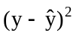 for the two lines.
Let = 10 + x:
x | y |  | 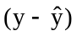
2 | 10 | 12 | -2 | 4
3 | 12 | 13 | -1 | 1
4 | 20 | 14 | 6 | 36
5 | 16 | 15 | 1 | 1
 |  |  |  | sum = 42
Let = 8 + 2x:
x | y
2 | 10 | 12 | -2 | 4
3 | 12 | 14 | -2 | 4
4 | 20 | 16 | 4 | 16
5 | 16 | 18 | -2 | 4
 |  |  |  | sum = 28
Using the least squares criterion, the second regression line fits the data better.

An important note to readers using pocket calculators for some of the solutions in this chapter:
To get calculator-based results that are as close as possible to those of Minitab, Excel and other computer packages, we have sometimes had to carry along many more significant digits than are shown in the arithmetic expressions themselves. For example, you may see a regression coefficient expressed as 0.00333 when in fact we are still carrying it along as the more exact 0.003328198623 in our calculations. If your calculator carries 10 significant digits, and you carry as many digits as possible through your sequence of calculations in any given exercise, you should arrive at the same results we obtained on the calculator and be extremely close to those generated by the computer.

15.6 c/a/m The table below shows the calculations to determine the least squares regression line.
x | y | xy | x² | y²
2 | 10 | 20 | 4 | 100
3 | 12 | 36 | 9 | 144
4 | 20 | 80 | 16 | 400
5 | 16 | 80 | 25 | 256
Σ x = 14 | Σ y = 58 | Σ xy = 216 | Σ x² = 54 | Σ y² = 900

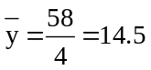 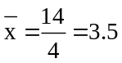 slope, 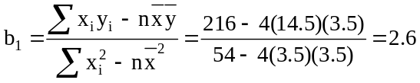
y-intercept,

Using the regression line, = 5.4 + 2.6x, the sum of the squared error terms is 25.20:
x | y
2 | 10 | 10.6 | -0.6 | 0.36
3 | 12 | 13.2 | -1.2 | 1.44
4 | 20 | 15.8 | 4.2 | 17.64
5 | 16 | 18.4 | -2.4 | 5.76
 |  |  |  | sum = 25.20

15.7 c/a/m The tables below show the sum of squares value for each line.
Let = 5 + 3x:
x | y
3 | 8 | 14 | -6 | 36
5 | 18 | 20 | -2 | 4
7 | 30 | 26 | 4 | 16
9 | 32 | 32 | 0 | 0
 |  |  |  | sum = 56
Let = -2 + 4x:
x | y
3 | 8 | 10 | -2 | 4
5 | 18 | 18 | 0 | 0
7 | 30 | 26 | 4 | 16
9 | 32 | 34 | -2 | 4
 |  |  |  | sum = 24
Using the least squares criterion, the second line fits the data better.

15.8 c/a/m The table below details the calculation of the least squares regression line.
x | y | xy | x² | y²
3 | 8 | 24 | 9 | 64
5 | 18 | 90 | 25 | 324
7 | 30 | 210 | 49 | 900
9 | 32 | 288 | 81 | 1024
Σ x = 24 | Σ y = 88 | Σ xy = 612 | Σ x² = 164 | Σ y² = 2312

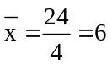 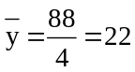 slope, 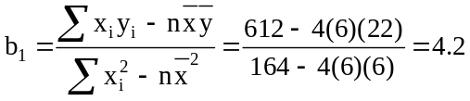
y-intercept, 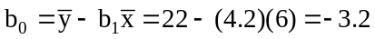

Using the regression line, = -3.2 + 4.2x, the sum of squares for this line is 23.20:
x | y
3 | 8 | 9.4 | -1.4 | 1.96
5 | 18 | 17.8 | 0.2 | 0.04
7 | 30 | 26.2 | 3.8 | 14.44
9 | 32 | 34.6 | -2.6 | 6.76
 |  |  |  | sum = 23.20

15.9 p/a/m This exercise can be solved using a pocket calculator and the method shown in the solution to exercise 15.8.
Method 1. Using the regression formulas and a calculator:
x | y | xy | x²
6.00 | 300.00 | 1800.00 | 36.00
12.00 | 408.00 | 4896.00 | 144.00
14.00 | 560.00 | 7840.00 | 196.00
6.00 | 252.00 | 1512.00 | 36.00
9.00 | 288.00 | 2592.00 | 81.00
13.00 | 650.00 | 8450.00 | 169.00
15.00 | 630.00 | 9450.00 | 225.00
9.00 | 522.00 | 4698.00 | 81.00
Σ x = 84.00 | Σ y = 3610.00 | Σ xy = 41,238.00 | Σ x² = 968.00

n = 8, = 10.5 and = 451.25
slope, 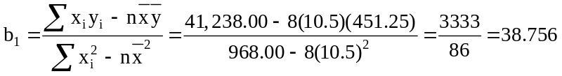

y-intercept,

The regression equation is = 44.314 + 38.756x

Method 2. Using Minitab and specifying a prediction for y when x is 10 years.

Regression Analysis: Shares versus Years

The regression equation is Shares = 44 + 38.8 Years

Predictor Coef SE Coef T P
Constant 44.3 108.5 0.41 0.697
Years 38.756 9.864 3.93 0.008

S = 91.4789 R-Sq = 72.0% R-Sq(adj) = 67.3%

Analysis of Variance
Source DF SS MS F P
Regression 1 129173 129173 15.44 0.008
Residual Error 6 50210 8368
Total 7 179384

Predicted Values for New Observations
New
Obs Fit SE Fit 95% CI 95% PI
1 431.9 32.7 (351.8, 511.9) (194.1, 669.6)

Values of Predictors for New Observations
New
Obs Years
1 10.0
a. To the greatest number of decimal places in the printout, the regression equation is
Shares = 44.3 + 38.756*Years. Since the slope is positive, we can deduce that the number of shares held increases as the number of years with the firm increases. Also, the value of the slope implies that for each additional year with the firm, the number of shares held increases by nearly 39 (38.756) shares.
b. Substituting Years = 10 into the equation in part a, the predicted value of Shares will be 431.9,
as shown in the "Fit" column of the printout.

Using Excel as described in Computer Solutions 2.7, we generate the corresponding Excel plot and equation shown below. Note that the default Excel equation shows the slope term and the intercept in reverse order compared to Minitab and the textbook. 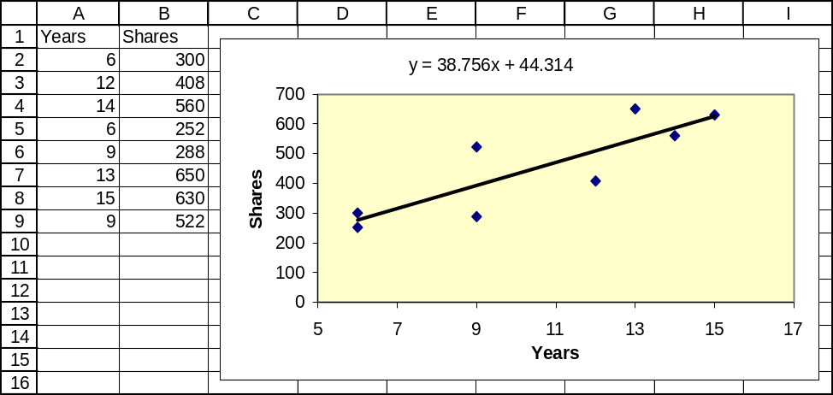

The Complete Excel regression printout.
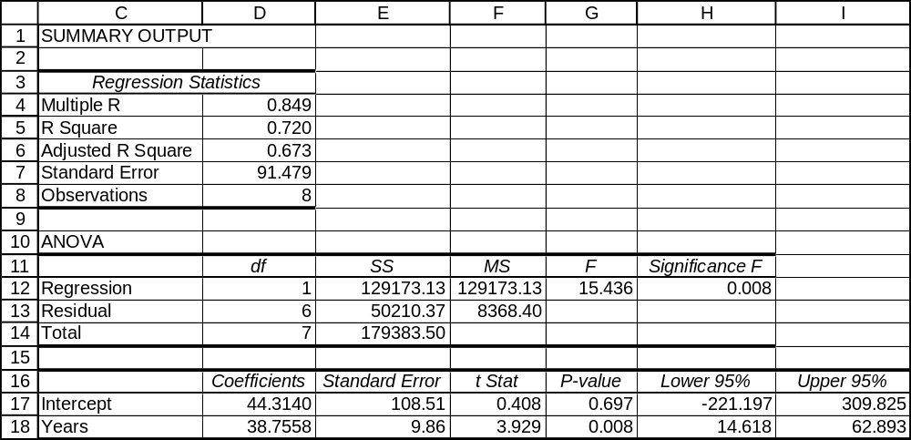

15.10 p/a/m This exercise can be solved using a pocket calculator and the method shown in the solution to exercise 15.9. We will use Minitab. In generating the printout shown below, we have specified that a prediction be made for trailer sales when boat sales = 500 thousand.

Regression Analysis: Trailers versus Boats

The regression equation is Trailers = - 166 + 0.577 Boats

Predictor Coef SE Coef T P
Constant -165.67 52.15 -3.18 0.034
Boats 0.57711 0.08686 6.64 0.003

S = 5.66591 R-Sq = 91.7% R-Sq(adj) = 89.6%

Analysis of Variance
Source DF SS MS F P
Regression 1 1417.1 1417.1 44.14 0.003
Residual Error 4 128.4 32.1
Total 5 1545.5

Predicted Values for New Observations
New
Obs Fit SE Fit 95% CI 95% PI
1 122.89 8.97 (97.97, 147.80) (93.42, 152.35)XX

XX denotes a point that is an extreme outlier in the predictors.

Values of Predictors for New Observations
New
Obs Boats
1 500

a. To the greatest number of decimal places in the printout, the regression equation is
Trailers = -165.67 + 0.57711*Boats. Since the slope is positive, we can deduce that boat trailer sales increase as boat sales increase. Moreover, the value of the slope implies that for every additional thousand boats sold, there are 0.57711 additional thousands of trailers sold.
b. Substituting Boats = 500 thousand into the equation in part a, the estimated value of Trailers will be 122.89 thousand, as shown in the "Fit" column of the printout.
c. Perhaps boat owners do not buy a new trailer every time they buy a new boat. Alternatively, boat owners might make their own trailers or they may haul their boats in the back of a truck or on the roof of their car or truck.

Applying the procedure described in textbook chapter 2, Computer Solutions 2.7, we obtain the corresponding Excel plot and equation shown below.
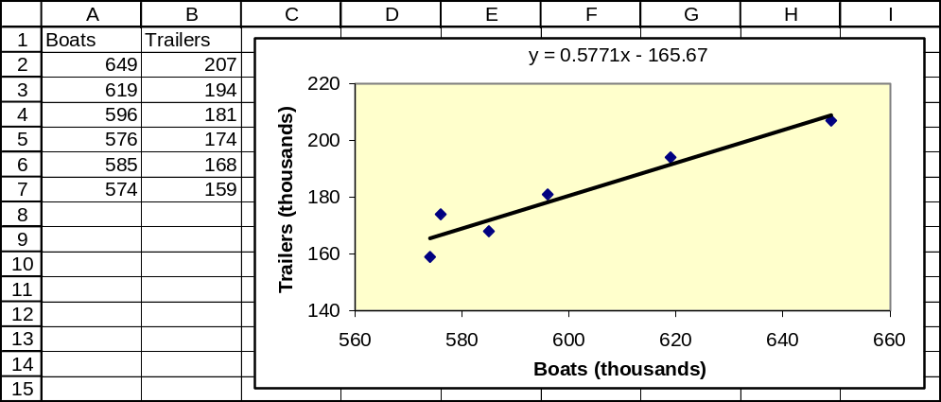
15.11 p/a/m This exercise can be solved using a pocket calculator and the method shown in the solution to exercise 15.9. We will use Minitab. In generating the printout shown below, we have specified that a prediction be made for total gross sales when sales after two weeks = $100 million.

Regression Analysis: totgross versus 2weeks

The regression equation is totgross = 110 + 1.05 2weeks

Predictor Coef SE Coef T P
Constant 110.02 28.25 3.89 0.030
2weeks 1.0485 0.3005 3.49 0.040

S = 14.3477 R-Sq = 80.2% R-Sq(adj) = 73.6%

Analysis of Variance

Source DF SS MS F P
Regression 1 2506.0 2506.0 12.17 0.040
Residual Error 3 617.6 205.9
Total 4 3123.5

Predicted Values for New Observations
New
Obs Fit SE Fit 95% CI 95% PI
1 214.87 6.90 (192.91, 236.83) (164.20, 265.54)

Values of Predictors for New Observations

New
Obs 2weeks
1 100

The regression equation is totgross = 110.02 + 1.0485*2weeks. Substituting 2weeks = 100 million into the equation, we obtain $214.87 million as the estimated total gross sales for a film that had $100 million in ticket sales during the first two weeks of its run. The corresponding Excel plot and regression summary are shown below.

Applying the procedure described in Computer Solutions 2.7, we obtain the corresponding Excel plot and equation shown below.
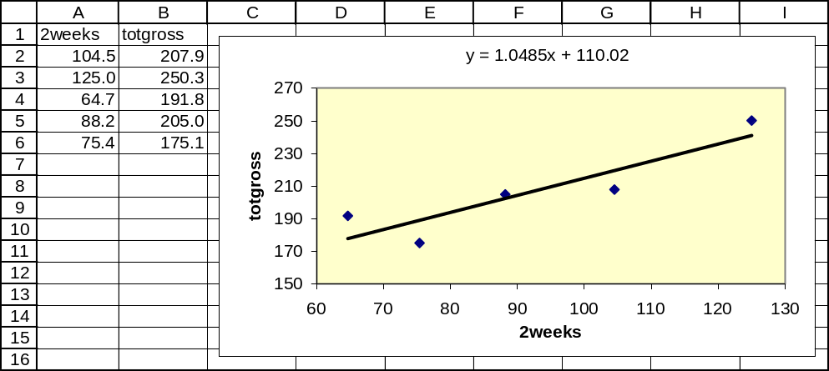

The complete Excel regression summary.
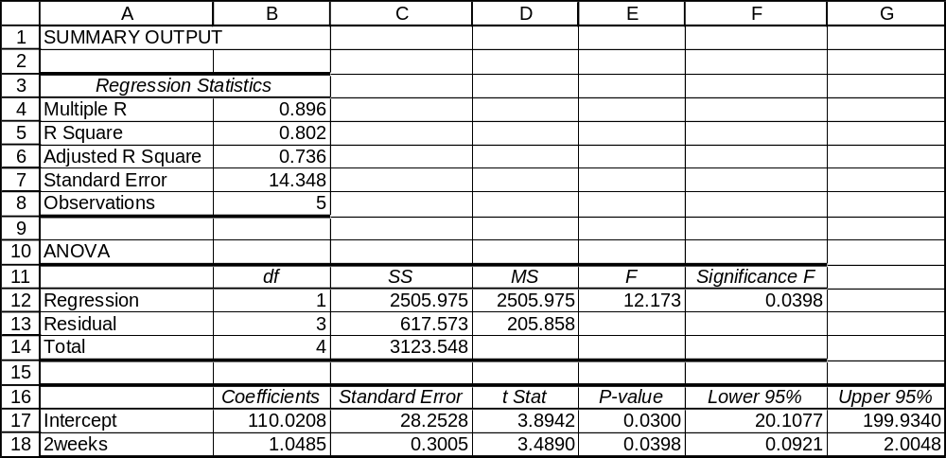

15.12 p/c/m In generating the Minitab printout shown below, we have specified that a prediction be made for gross revenue for a firm with 200 equity partners.

Regression Analysis: gross_revenue versus partners

The regression equation is gross_revenue = 28.0 + 3.81 partners

Predictor Coef SE Coef T P
Constant 27.99 64.06 0.44 0.663
partners 3.8074 0.2881 13.21 0.000

S = 301.833 R-Sq = 64.0% R-Sq(adj) = 63.7%

Analysis of Variance
Source DF SS MS F P
Regression 1 15906062 15906062 174.59 0.000
Residual Error 98 8928118 91103
Total 99 24834180

Unusual Observations
Obs partners gross_revenue Fit SE Fit Residual St Resid
6 401 2358.5 1554.8 66.3 803.7 2.73R
10 440 2588.5 1703.2 76.5 885.3 3.03RX
15 395 2660.5 1531.9 64.8 1128.6 3.83R
19 445 2005.5 1722.3 77.8 283.2 0.97 X
20 363 2034.5 1410.1 56.8 624.4 2.11R
60 711 2188.0 2735.1 151.4 -547.1 -2.10RX
85 510 1441.0 1969.8 95.4 -528.8 -1.85 X
86 356 649.5 1383.4 55.1 -733.9 -2.47R
100 248 305.0 972.2 33.7 -667.2 -2.22R
R denotes an observation with a large standardized residual.
X denotes an observation whose X value gives it large leverage.

Predicted Values for New Observations
New
Obs Fit SE Fit 90% CI 90% PI
1 789.5 30.2 (739.3, 839.6) (285.8, 1293.2)

Values of Predictors for New Observations
New
Obs partners
1 200

The regression equation is gross_revenue = 27.99 + 3.8074*partners. Substituting 200 partners into this equation, we obtain an estimate of $789.5 million in gross revenue.
15.13 p/c/m In generating the Minitab printout shown below, we have specified that a prediction be made for the number of acres burned during a January-May period having 18 inches of rainfall.

Regression Analysis: AcresBurned versus RainInches

The regression equation is AcresBurned = 349550 - 7851 RainInches

Predictor Coef SE Coef T P
Constant 349550 179579 1.95 0.078
RainInches -7851 9902 -0.79 0.445

S = 185098 R-Sq = 5.4% R-Sq(adj) = 0.0%

Analysis of Variance
Source DF SS MS F P
Regression 1 21539746092 21539746092 0.63 0.445
Residual Error 11 3.76873E+11 34261159213
Total 12 3.98412E+11

Unusual Observations
Obs RainInches AcresBurned Fit SE Fit Residual St Resid
2 12.1 645331 254861 73546 390470 2.30R
4 30.1 86948 113142 136122 -26194 -0.21 X

R denotes an observation with a large standardized residual.
X denotes an observation whose X value gives it large influence.

Predicted Values for New Observations
New
Obs Fit SE Fit 95% CI 95% PI
1 208223 51704 (94423, 322024) (-214770, 631217)

Values of Predictors for New Observations
New
Obs RainInches
1 18.0

The regression equation is AcresBurned = 349550 - 7851 RainInches. Substituting RainInches = 18 into the equation, we obtain an estimate of 208,223 for AcresBurned. The corresponding Excel plot and equation are shown below.
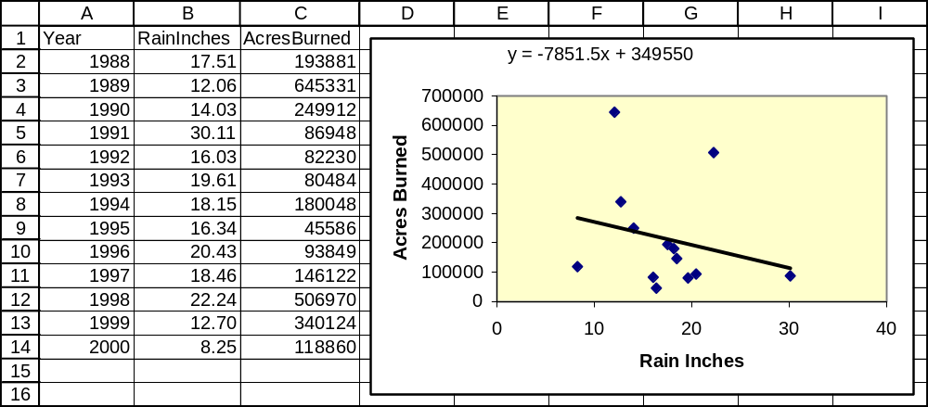

15.14 p/c/m In generating the Minitab printout shown below, we have specified that a prediction be made for total enrollment for an HMO firm that administers 20 plans.

Regression Analysis: HMOEnrolled versus NumbPlans

The regression equation is HMOEnrolled = 510653 + 125389 NumbPlans

Predictor Coef SE Coef T P
Constant 510653 573196 0.89 0.385
NumbPlans 125389 21577 5.81 0.000

S = 1928588 R-Sq = 65.2% R-Sq(adj) = 63.3%

Analysis of Variance
Source DF SS MS F P
Regression 1 1.25605E+14 1.25605E+14 33.77 0.000
Residual Error 18 6.69502E+13 3.71945E+12
Total 19 1.92555E+14

Unusual Observations
Obs NumbPlans HMOEnrolled Fit SE Fit Residual St Resid
1 85.0 13317160 11168676 1518958 2148484 1.81 X
2 12.0 8054722 2015315 447276 6039407 3.22R

R denotes an observation with a large standardized residual.
X denotes an observation whose X value gives it large influence.

Predicted Values for New Observations
New
Obs Fit SE Fit 95% CI 95% PI
1 3018423 434606 (2105350, 3931497) (-1134997, 7171843)

Values of Predictors for New Observations
New
Obs NumbPlans
1 20.0

The regression equation is HMOEnrolled = 510653 + 125389*NumbPlans. For a firm that administers 20 plans, we substitute NumbPlans = 20 into the equation and estimate that the firm has a total enrollment of HMOEnrolled = 3,018,423 persons.

15.15 d/p/m The standard error of the estimate is a measure which describes the dispersion of the data points above and below the regression line. The standard error may be used as a measure of how well the regression line fits the data. In addition, the standard error is used in calculating confidence intervals for the mean value of y given a specific value of x, and in calculating the prediction interval for an individual y observation.

15.16 d/p/d The standard error of the estimate will be zero only when every data point falls on the regression line, that is, when the sum of the squared residual terms is also zero.

15.17 d/p/d A confidence interval provides a range of possible values for the mean value of y given a specific value of x. The point estimate for the mean will fall on the regression line. A prediction interval provides a range of possible values for an individual observation of y given a value of x.

15.18 d/p/d For a given value of x, the prediction interval will always be wider than the confidence interval. The confidence interval is concerned with the mean value of y only; the prediction interval is concerned with all of the possible values of y.

15.19 d/p/d The prediction interval for y gets wider as the x value on which the interval estimate is based gets farther away from the mean of x because there is less error in making interval estimates based on x values that are closer to the mean. This can be seen in the formula; the numerator of the fraction under the square root includes (x - )² . This value, of course, increases as the x value moves away from the mean.

15.20 c/a/e The standard error of the estimate is 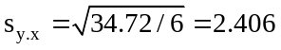.

15.21 c/a/m
a. To determine the least squares regression line, we must calculate the slope and y-intercept.
slope, 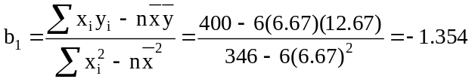
y-intercept,
The regression equation is = 21.701 - 1.354x
b. The standard error of the estimate is
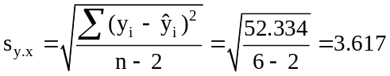
c. To calculate the confidence interval for the mean of y, we must first calculate the estimated value of y: = 21.701 - 1.354(7) = 12.223.
We also need the t-value with 6 - 2 = 4 degrees of freedom for a 95% interval; this value is 2.776.
Therefore the 95% confidence interval for the mean value of y when x = 7 is:
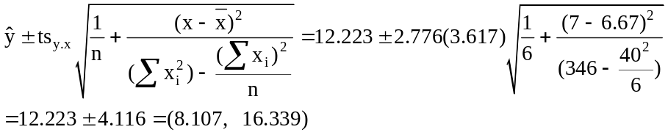
d. To calculate the confidence interval for the mean of y, we must first calculate the estimated value of y: = 21.701 - 1.354(9) = 9.515.
We also need the t-value with 6 - 2 = 4 degrees of freedom for a 95% interval; this value is 2.776. Therefore the 95% confidence interval for the mean value of y when x = 9 is:
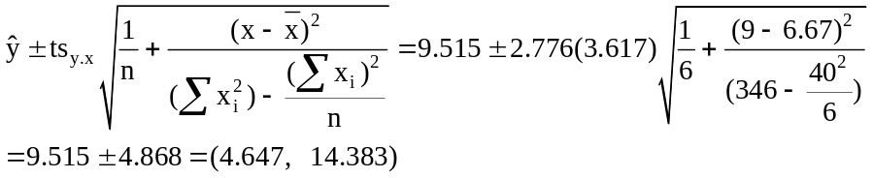
e. The confidence interval in d is wider because 9 is farther from the mean of x than 7.

15.22 c/a/m Recall the data from exercise 15.21. The regression line is: = 21.701 - 1.354x, and the standard error of the estimate is 3.617. The construction of the prediction interval is very similar to that for the confidence interval.
a. To calculate the prediction interval for an individual y value, we must first calculate the estimated value of y when x = 2: = 21.701 - 1.354(2) = 18.993.
We also need the t-value with 6 - 2 = 4 degrees of freedom for a 95% interval; this value is 2.776. Therefore, the 95% prediction interval for an individual y value when x = 2 is:
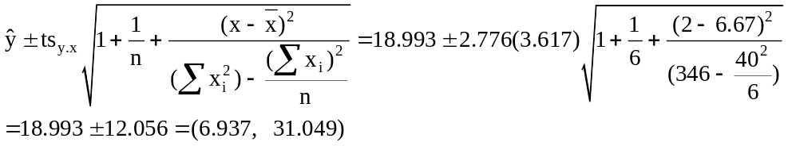
b. To calculate the prediction interval for an individual y value, we must first calculate the estimated value of y when x = 3: = 21.701 - 1.354(3) = 17.639.
We also need the t-value with 6 - 2 = 4 degrees of freedom for a 95% interval; this value is 2.776. Therefore, the 95% prediction interval for an individual y value when x = 3 is:
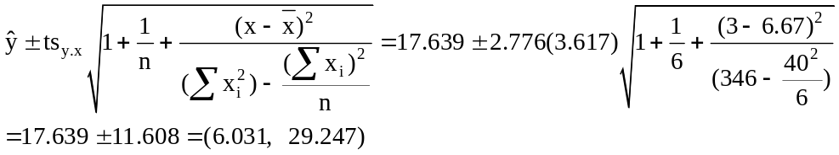
c. To calculate the prediction interval for an individual y value, we must first calculate the estimated value of y when x = 4: = 21.701 - 1.354(4) = 16.285.
We also need the t-value with 6 - 2 = 4 degrees of freedom for a 95% interval; this value is 2.776. Therefore, the 95% prediction interval for an individual y value when x = 4 is:
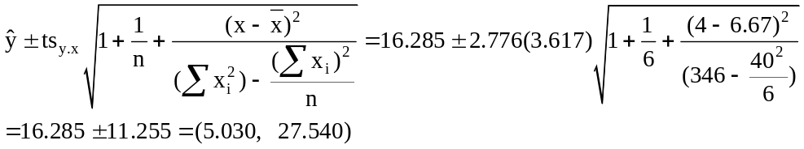

15.23 p/a/m One way to solve this exercise is with the regression formulas and a pocket calculator:
x = TD% | y = Rating | xy | x² | y²
5.6 | 96.8 | 542.08 | 31.36 | 9370.24
5.7 | 94.7 | 539.79 | 32.49 | 8968.09
5.1 | 93.2 | 475.32 | 26.01 | 8686.24
5.4 | 92.9 | 501.66 | 29.16 | 8630.41
5.2 | 92.3 | 479.96 | 27.04 | 8519.29
5.1 | 90.1 | 459.51 | 26.01 | 8118.01
4.9 | 89.9 | 420.00 | 24.01 | 8082.01
Σ x = 37.0 | Σ y = 649.9 | Σ xy = 3438.83 | Σx² = 196.08 | Σ y² = 60,374.29

n = 7, = 5.28579. and = 92.84286
slope, 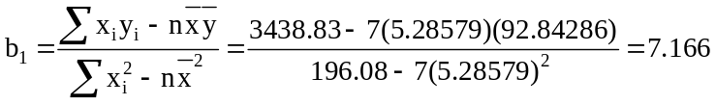

y-intercept,
The regression equation is = 54.97 +7.166x

In generating the Minitab printout below, we have specified point and 95% interval estimates for Rating when TD% = 5.0.

Regression Analysis: Rating versus TD%

The regression equation is Rating = 55.0 + 7.17 TD%

Predictor Coef SE Coef T P
Constant 54.97 10.29 5.34 0.003
TD% 7.166 1.943 3.69 0.014

S = 1.38587 R-Sq = 73.1% R-Sq(adj) = 67.7%

Analysis of Variance
Source DF SS MS F P
Regression 1 26.114 26.114 13.60 0.014
Residual Error 5 9.603 1.921
Total 6 35.717

Predicted Values for New Observations
New
Obs Fit SE Fit 95% CI 95% PI
1 90.796 0.763 (88.833, 92.758) (86.728, 94.863)

Values of Predictors for New Observations
New
Obs TD%
1 5.00

a. To the greatest number of decimal places in the Minitab printout, the regression equation is
Rating = 54.97 + 7.166*TD%.
b. Substituting TD% = 5.0 into the regression equation, the estimated value of Rating will be 90.796,
as shown in the "Fit" column of the printout.
c. The Minitab printout shows the standard error of the estimate to be 1.38587 rating points. Using a calculator and the formula in the text:
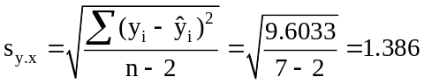
(Please note once again the calculator-solution commentary on the first page of this chapter's solution manual materials. As mentioned in that discussion, we are carrying more decimal places than practicality allows us to show.)
d. For a quarterback with TD% = 5.0, the 95% prediction interval for his quarterback rating will be from 86.728 to 94.863, as shown in the "PI" column of the Minitab printout. Using a calculator and the formula in the text:
When x = 5.0, = 54.97 + 7.166(5.0) = 90.80, and d.f. = n - 2 = 5, then t = 2.571 for a 95% prediction interval:
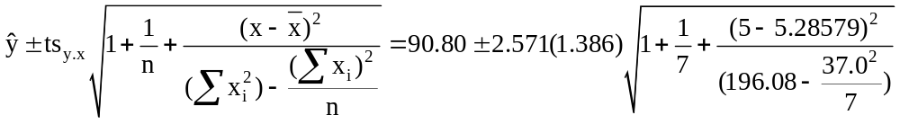
or from 86.728 to 94.863.

e. For all quarterbacks with TD% = 5.0, the 95% confidence interval for their mean rating will be from 88.833 to 92.758, as shown in the "CI" column of the Minitab printout. Using a calculator and the formula in the text:
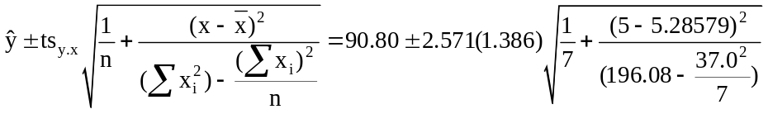
or from 88.833 to 92.758.

For this exercise, the detailed Excel regression printout is shown below. Although it does not provide confidence and prediction intervals, it does provide the other items shown earlier. The Excel printout provides a 95% confidence interval for the intercept and the slope of the population regression equation. The square of the standard error of the estimate is shown in the "Residual" row, "MS" column as 1.921. Its positive square root (1.386) is listed as the standard error of the estimate.
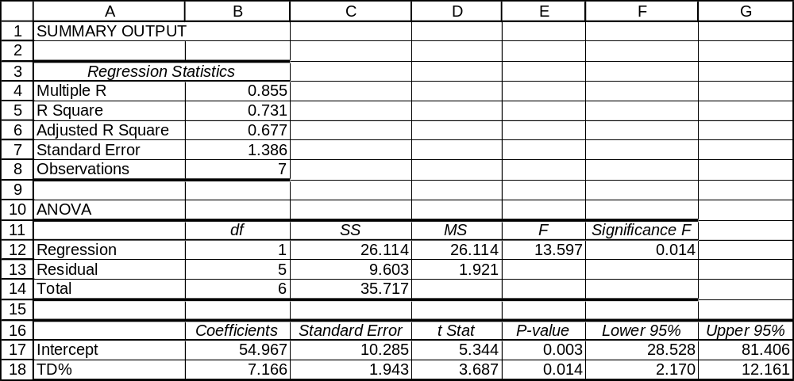

We can also use Data Analysis Plus for the point estimate and the 95% PI and CI estimates in parts b, d, and e. The values are comparable to those from Minitab, and the printout is shown below.
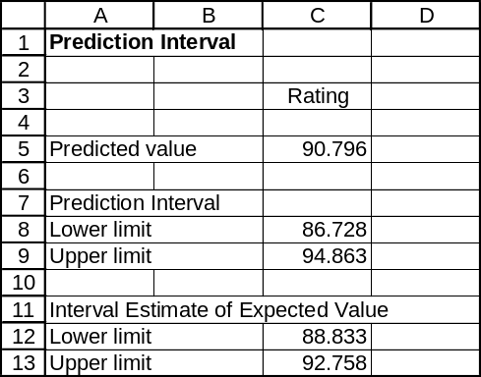

15.24 p/a/m In generating the Minitab printout below, we have specified point and 95% interval estimates for Rating when Inter% = 3.0.

Regression Analysis: Rating versus Int%

The regression equation is Rating = 102 - 3.06 Int%

Predictor Coef SE Coef T P
Constant 101.628 7.596 13.38 0.000
Int% -3.060 2.627 -1.16 0.297

S = 2.37041 R-Sq = 21.3% R-Sq(adj) = 5.6%

Analysis of Variance
Source DF SS MS F P
Regression 1 7.623 7.623 1.36 0.297
Residual Error 5 28.094 5.619
Total 6 35.717

Predicted Values for New Observations
New
Obs Fit SE Fit 95% CI 95% PI
1 92.449 0.957 (89.988, 94.911) (85.878, 99.021)

Values of Predictors for New Observations
New
Obs Int%
1 3.00

a. To the greatest number of decimal places in the printout, the regression equation is
Rating = 101.628 – 3.060*Int%.
b. Substituting Int% = 3.0 into the equation in part a, the estimated value of Rating is:
Rating = 101.628 - 3.060(3.0) = 92.449, as shown in the "Fit" portion of the printout.
c. The printout shows the standard error of the estimate is 2.37041 rating points.
d. For a quarterback with Int% = 3.0, the 95% prediction interval for his quarterback rating will be from
85.878 to 99.021, as shown in the "PI" column of the Minitab printout.
e. For all quarterbacks with Int% = 3.0, the 95% confidence interval for their mean rating will be from 89.988 to 94.911, as shown in the "CI" column of the Minitab printout.

For this exercise, the detailed Excel regression printout is shown below. Although it does not provide confidence and prediction intervals, it does provide the other items shown earlier. The Excel printout provides a 95% confidence interval for the intercept and the slope of the population regression equation. The square of the standard error of the estimate is shown in the "Residual" row, "MS" column as 5.619. Its positive square root (2.370) is listed as the standard error of the estimate.

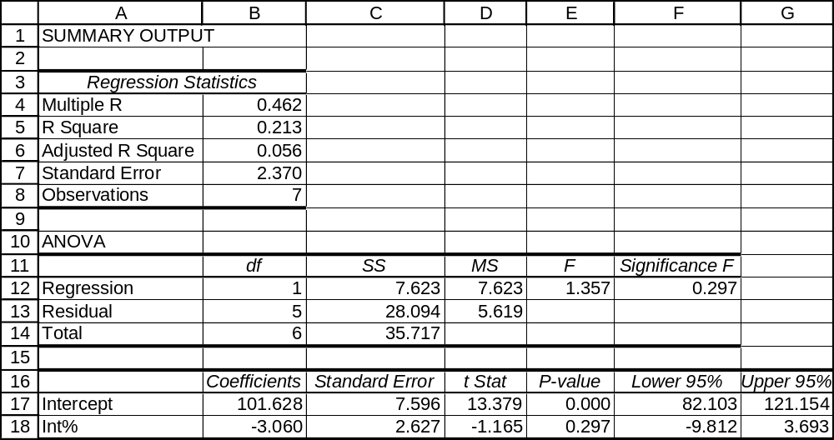

We can also use Data Analysis Plus for the point estimate and the 95% PI and CI estimates in parts b, d, and e. The values are comparable to those from Minitab, and the printout is shown below.
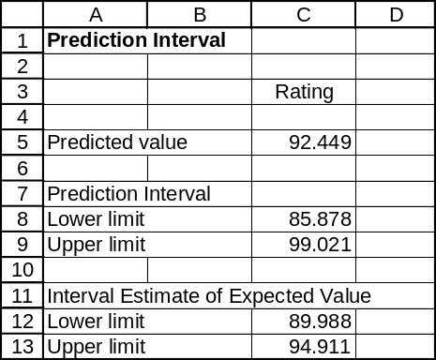

15.25 p/a/m Shown below are relevant preliminary calculations for pocket-calculator solutions to this exercise. We have included y² values with those presented earlier, in the solution to exercise 15.9.
x | y | xy | x² | y²
6.00 | 300.00 | 1800.00 | 36.00 | 90,000.00
12.00 | 408.00 | 4896.00 | 144.00 | 166,464.00
14.00 | 560.00 | 7840.00 | 196.00 | 313,600.00
6.00 | 252.00 | 1512.00 | 36.00 | 63,504.00
9.00 | 288.00 | 2592.00 | 81.00 | 82,944.00
13.00 | 650.00 | 8450.00 | 169.00 | 422,500.00
15.00 | 630.00 | 9450.00 | 225.00 | 396,900.00
9.00 | 522.00 | 4698.00 | 81.00 | 272,484.00
Σ x = 84.00 | Σ y = 3610.00 | Σ xy = 41,238.00 | Σ x² = 968.00 | Σ y² = 1,808,396.00

n = 8, = 10.5 and = 451.25
slope,

y-intercept,
The regression equation is = 44.314 + 38.756x and
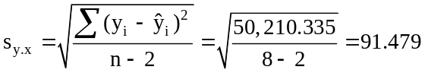
The prediction interval for the amount of stock owned when x = 5:
When x = 5, = 44.314 + 38.756(5) = 238.09. With n = 8, d.f. = n - 2 = 6, the t-value for the 95% prediction interval is 2.447, and the interval can be calculated as:
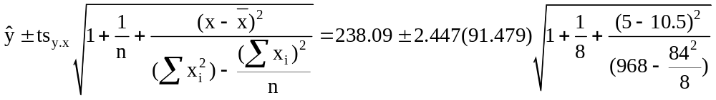
or from -33.9 to 510.1

In the Minitab printout below, point and 95% interval estimates are shown for Shares when Years = 5.0.

Regression Analysis: Shares versus Years

The regression equation is Shares = 44 + 38.8 Years

Predictor Coef SE Coef T P
Constant 44.3 108.5 0.41 0.697
Years 38.756 9.864 3.93 0.008

S = 91.4789 R-Sq = 72.0% R-Sq(adj) = 67.3%

Analysis of Variance
Source DF SS MS F P
Regression 1 129173 129173 15.44 0.008
Residual Error 6 50210 8368
Total 7 179384

Predicted Values for New Observations
New
Obs Fit SE Fit 95% CI 95% PI
1 238.1 63.2 (83.5, 392.6) (-33.9, 510.1)

Values of Predictors for New Observations
New
Obs Years
1 5.00

We can also use Data Analysis Plus for the point estimate and the 95% PI and CI estimates.
The results are comparable to those reported by Minitab and the printout is shown below.
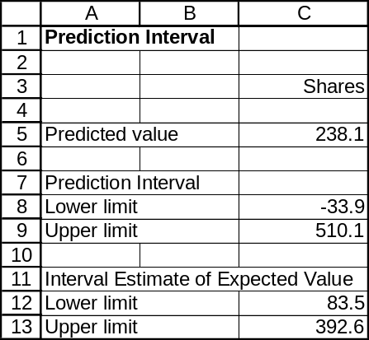

15.26 p/a/m The Minitab regression result from exercise 15.10 is repeated below. We have specified that point and interval estimates be made for trailer sales when boat sales = 500 thousand.

Regression Analysis: Trailers versus Boats

The regression equation is Trailers = - 166 + 0.577 Boats

Predictor Coef SE Coef T P
Constant -165.67 52.15 -3.18 0.034
Boats 0.57711 0.08686 6.64 0.003

S = 5.66591 R-Sq = 91.7% R-Sq(adj) = 89.6%

Analysis of Variance
Source DF SS MS F P
Regression 1 1417.1 1417.1 44.14 0.003
Residual Error 4 128.4 32.1
Total 5 1545.5

Predicted Values for New Observations
New
Obs Fit SE Fit 95% CI 95% PI
1 122.89 8.97 (97.97, 147.80) (93.42, 152.35)XX

XX denotes a point that is an extreme outlier in the predictors.

Values of Predictors for New Observations
New
Obs Boats
1 500

The standard error of estimate is 5.66591 thousand trailers. For Boats = 500 thousand, the estimated value
of Trailers is 122.89 thousand (see the "Fit" column in the printout). For an individual year with this level of boat sales, the 95% prediction interval for trailer sales is from 93.42 thousand to 152.35 thousand (see the "PI" column of the printout).

We can also use Data Analysis Plus for the point estimate and the 95% PI and CI estimates.
The results are comparable to those reported by Minitab and the printout is shown below.
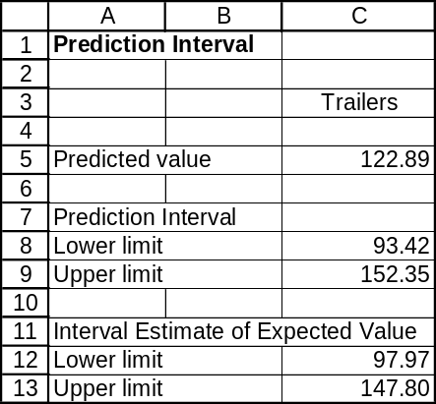

15.27 p/c/m The Minitab printout is shown below. We have specified point and interval estimates for total revenue associated with a dealership group consisting of 100 dealers.

Regression Analysis: $GroupRevenue versus NumDealrs

The regression equation is $GroupRevenue = - 1.66E+08 + 64076803 NumDealrs

Predictor Coef SE Coef T P
Constant -166227473 72426532 -2.30 0.024
NumDealrs 64076803 2030145 31.56 0.000

S = 641757544 R-Sq = 91.2% R-Sq(adj) = 91.1%

Analysis of Variance
Source DF SS MS F P
Regression 1 4.10289E+20 4.10289E+20 996.20 0.000
Residual Error 96 3.95379E+19 4.11853E+17
Total 97 4.49827E+20

Unusual Observations
Obs NumDealrs $GroupRevenue Fit SE Fit Residual St Resid
1 290 20926200000 18416045305 560209649 2510154695 8.02RX
4 114 3100030000 7138528033 209426763 -4038498033 -6.66RX
9 45 1242660000 2717228647 87696854 -1474568647 -2.32R

R denotes an observation with a large standardized residual.
X denotes an observation whose X value gives it large influence.

Predicted Values for New Observations
New
Obs Fit SE Fit 95% CI
1 6241452795 182612760 (5878969331, 6603936259)
New
Obs 95% PI
1 (4917005327, 7565900263)X
X denotes a point that is an outlier in the predictors.

Values of Predictors for New Observations
New
Obs NumDealrs
1 100

For a dealership group consisting of 100 dealers, the point estimate for total revenue is
$GroupRevenue = -166,227,473 + 64,076,803(100) = $6,241,452,795, or $6.24 billion.
For this dealership group, the 95% prediction interval for total revenue is from
$4,917,005,327 to $7,565,900,263, or from $4.92 billion to 7.57 billion.
For all dealership groups like this one, the 95% confidence interval for their mean total revenue is from
$5,878,969,331 to $6,603,936,259, or from $5.88 billion to $6.60 billion.
We can also use Data Analysis Plus for the point estimate and the 95% PI and CI estimates.
The results are comparable to those reported by Minitab and the printout is shown below.
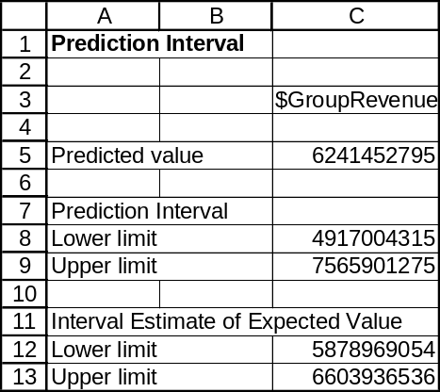

15.28 p/c/m The Minitab printout is shown below. We have specified point and interval estimates for total revenue associated with a dealership group for which the average number of retail units sold per dealer is 1000.

Regression Analysis: $GroupRevenue versus AvgRetail/Dealer

The regression equation is $GroupRevenue = 8.29E+08 + 15875 AvgRetail/Dealer

Predictor Coef SE Coef T P
Constant 828663849 419024770 1.98 0.051
AvgRetail/Dealer 15875 232061 0.07 0.946

S = 2164593622 R-Sq = 0.0% R-Sq(adj) = 0.0%

Analysis of Variance
Source DF SS MS F P
Regression 1 2.19271E+16 2.19271E+16 0.00 0.946
Residual Error 96 4.49805E+20 4.68547E+18
Total 97 4.49827E+20

Unusual Observations
Obs AvgRetail/Dealer $GroupRevenue Fit SE Fit Residual
1 1617 20926200000 854337041 219383370 20071862959
11 5281 987415000 912493839 895086908 74921161
23 4172 616372000 894886779 648561011 -278514779
28 4884 491776000 906202542 806220618 -414426542
65 4504 558491000 900157308 721562173 -341666308
78 3918 203386000 890862444 593509232 -687476444

Obs St Resid
1 9.32R
11 0.04 X
23 -0.13 X
28 -0.21 X
65 -0.17 X
78 -0.33 X

R denotes an observation with a large standardized residual.
X denotes an observation whose X value gives it large influence.

Predicted Values for New Observations
New
Obs Fit SE Fit 95% CI 95% PI
1 844538937 252058537 (344206695, 1344871179) (-3481178231, 5170256105)

Values of Predictors for New Observations
New
Obs AvgRetail/Dealer
1 1000

For a dealership group for which the average number of retail units sold per dealer is 1000, the point estimate for total revenue is $GroupRevenue = 828,663,849 + 15,875(1000) = $844,538,937, or $844.54 million.
For this dealership group, the 95% prediction interval for total revenue is from -$3,481,178,231 to $5,170,256,105, or from -$3.48 billion to $5.17 billion.
For all dealership groups like this one, the 95% confidence interval for their mean total revenue is from $344,206,695 to $1,344,871,179, or from $0.34 billion to $1.34 billion.

We can also use Data Analysis Plus for the point estimate and the 95% PI and CI estimates.
The results are comparable to those reported by Minitab and the printout is shown below.
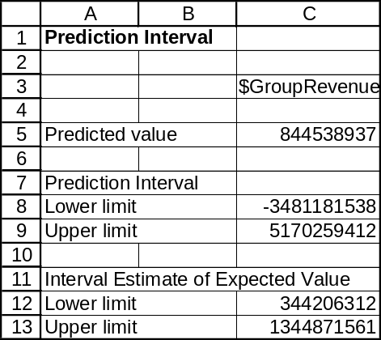

15.29 p/c/m The Minitab printout is shown below. We have specified point and interval estimates for burned acreage when the January-May rainfall is 20 inches.

Regression Analysis: AcresBurned versus RainInches

The regression equation is AcresBurned = 349550 - 7851 RainInches

Predictor Coef SE Coef T P
Constant 349550 179579 1.95 0.078
RainInches -7851 9902 -0.79 0.445

S = 185098 R-Sq = 5.4% R-Sq(adj) = 0.0%

Analysis of Variance
Source DF SS MS F P
Regression 1 21539746092 21539746092 0.63 0.445
Residual Error 11 3.76873E+11 34261159213
Total 12 3.98412E+11

Unusual Observations
Obs RainInches AcresBurned Fit SE Fit Residual St Resid
2 12.1 645331 254861 73546 390470 2.30R
4 30.1 86948 113142 136122 -26194 -0.21 X

R denotes an observation with a large standardized residual.
X denotes an observation whose X value gives it large influence.
Predicted Values for New Observations
New
Obs Fit SE Fit 90% CI 90% PI
1 192521 57527 (89209, 295832) (-155578, 540619)

Values of Predictors for New Observations
New
Obs RainInches
1 20.0

The point estimate for burned acreage for a year during which January-May rainfall is 20 inches is
AcresBurned = 349,550 - 7851*20 = 192,521 acres.
For a year during which January-May rainfall is 20 inches, the 90% prediction interval for the number of acres burned is from -155,578 to 540,619 acres.
For all years during which January-May rainfall is 20 inches, the 90% confidence interval for the mean number of acres burned is from 89,209 to 295,832 acres.

We can also use Data Analysis Plus for the point estimate and the 90% PI and CI estimates.
The results are comparable to those reported by Minitab and the printout is shown below.
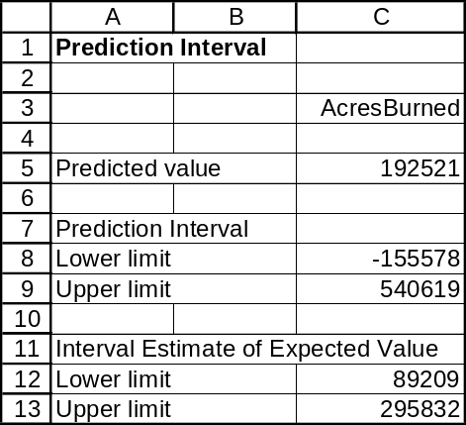

15.30 p/c/m The Minitab printout is shown below. We have specified point and interval estimates for gross revenue when there are 200 law partners.

Regression Analysis: gross_revenue versus partners

The regression equation is gross_revenue = 28.0 + 3.81 partners

Predictor Coef SE Coef T P
Constant 27.99 64.06 0.44 0.663
partners 3.8074 0.2881 13.21 0.000

S = 301.833 R-Sq = 64.0% R-Sq(adj) = 63.7%

Analysis of Variance
Source DF SS MS F P
Regression 1 15906062 15906062 174.59 0.000
Residual Error 98 8928118 91103
Total 99 24834180

Unusual Observations
Obs partners gross_revenue Fit SE Fit Residual St Resid
6 401 2358.5 1554.8 66.3 803.7 2.73R
10 440 2588.5 1703.2 76.5 885.3 3.03RX
15 395 2660.5 1531.9 64.8 1128.6 3.83R
19 445 2005.5 1722.3 77.8 283.2 0.97 X
20 363 2034.5 1410.1 56.8 624.4 2.11R
60 711 2188.0 2735.1 151.4 -547.1 -2.10RX
85 510 1441.0 1969.8 95.4 -528.8 -1.85 X
86 356 649.5 1383.4 55.1 -733.9 -2.47R
100 248 305.0 972.2 33.7 -667.2 -2.22R

R denotes an observation with a large standardized residual.
X denotes an observation whose X value gives it large leverage.

Predicted Values for New Observations
New
Obs Fit SE Fit 90% CI 90% PI
1 789.5 30.2 (739.3, 839.6) (285.8, 1293.2)

Values of Predictors for New Observations
New
Obs partners
1 200

The point estimate for gross revenue when there are 200 equity partners is
gross_revenue = 27.99 + 3.8074*partners = $789.5 million.
For an individual law firm having 200 equity partners, the 90% prediction interval for gross revenue is from $285.8 to $1293.2 million.
For all law firms having 200 equity partners, the 90% confidence interval for their mean gross revenue is $739.3 to $839.6 million.

We can also use Data Analysis Plus for the point estimate and the 90% PI and CI estimates.
The results are comparable to those reported by Minitab and the printout is shown below.
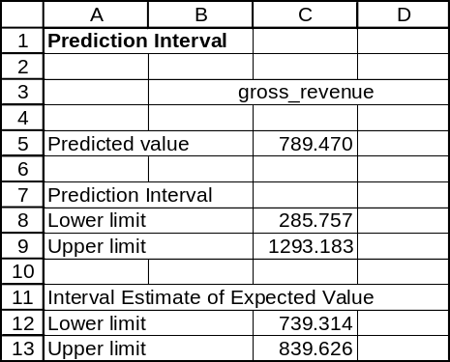

15.31 d/p/m The coefficient of correlation (r) describes both the direction and the strength of the linear relationship between two variables. The coefficient of determination (r²) expresses the proportion of the variation in the dependent variable (y) that is explained by the regression line,
= b₀ + b₁x, but it does not indicate the direction of the relationship.

15.32 c/a/e Since 64% of the variation in y is explained by x, 0.64 is the coefficient of determination.
The square root of the coefficient of determination, with the appropriate sign, is equal to the coefficient of correlation. Therefore, the coefficient of correlation is -0.80. We know this is negative because y and x are inversely related.

15.33 c/a/e The coefficient of determination is 0.81 (or the coefficient of correlation squared). This means that 81% of the variation in y is explained by x.

15.34 p/a/m
The Minitab printout is shown below.

Correlations: TD%, Int%

Pearson correlation of TD% and Int% = -0.642
P-Value = 0.120

The negative value for the coefficient of correlation implies that x and y are inversely related.
That is, as the interception percentage increases, the touchdown percentage decreases, and vice-versa.
The coefficient of determination [(-0.642)² = 0.412] indicates that 41.2% of the variation in touchdown percentage is explained by the variation in interception percentage. Based on these data, the relationship is inverse and it appears to be moderately strong, as a p-value of 0.120 is rather close to the levels many would typically associate with significance.

15.35 d/p/m Variation explained by the regression line (SSR) and variation not explained by the regression line (SSE) are the two components of the total variation in y (SST). The coefficient of determination can be expressed as: 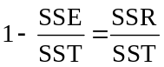

15.36 c/a/e The coefficient of determination is 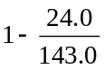, which is 1 - 0.168 = 0.832. This means that 83.2% of the variation in y is explained by x.

15.37 c/a/e
a. The least-squares regression line for predicting the rate of collision claims based on comprehensive
claim rating is shown in the Minitab printout below. We have also specified point and 90% interval
estimates associated with a comprehensive claim rating of 90.

Regression Analysis: Collision versus Comp

The regression equation is Collision = 24.5 + 0.955 Comp

Predictor Coef SE Coef T P
Constant 24.48 16.33 1.50 0.165
Comp 0.9551 0.1791 5.33 0.000

S = 6.99888 R-Sq = 74.0% R-Sq(adj) = 71.4%

Analysis of Variance
Source DF SS MS F P
Regression 1 1393.1 1393.1 28.44 0.000
Residual Error 10 489.8 49.0
Total 11 1882.9

Predicted Values for New Observations
New
Obs Fit SE Fit 90% CI 90% PI
1 110.44 2.02 (106.77, 114.10) (97.23, 123.64)

Values of Predictors for New Observations
New
Obs Comp
1 90.0

b. The Minitab and Excel printouts for the coefficient of correlation are shown below. The coefficient
of correlation is r = 0.860 and the coefficient of determination is r² = 0.740. Because r is positive,
the variables are directly related, with higher collision claim rates associated with higher
comprehensive claim rates. The value of r² tells us that 74.0% of the variation in collision claim rates
is explained by variation in comprehensive claim rates.

Correlations: Collision, Comp

Pearson correlation of Collision and Comp = 0.860
P-Value = 0.000

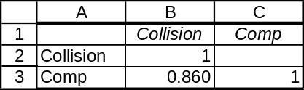

c. The Minitab printout in part (a) includes point and interval estimates when the comprehensive rating is 90. If a model were to have a comprehensive rating of 90, the point estimate for the collision rating would be 110.44, as shown in the “Fit” column near the bottom of the printout.

The comparable Excel printout is shown below:
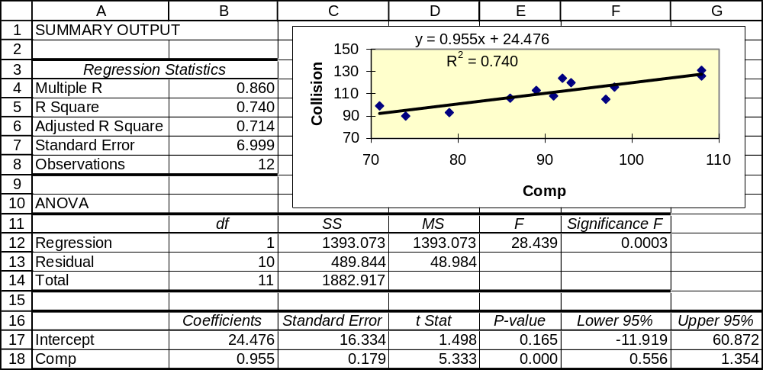

15.38 p/a/m
a. The least-squares regression line for predicting per-capita consumption of bottled water on the basis
of U.S. population is shown in the Minitab printout below. We have also specified point and 95% interval estimates associated with a U.S. population of 320 million. Because the slope of the equation is positive, r will be the positive square root of r² = 0.994, or r = 0.997.

Regression Analysis: Bott_Wat versus US_Pop

The regression equation is Bott_Wat = - 180 + 0.693 US_Pop

Predictor Coef SE Coef T P
Constant -179.622 8.870 -20.25 0.000
US_Pop 0.69302 0.03025 22.91 0.000

S = 0.261182 R-Sq = 99.4% R-Sq(adj) = 99.2%

Analysis of Variance
Source DF SS MS F P
Regression 1 35.815 35.815 525.03 0.000
Residual Error 3 0.205 0.068
Total 4 36.020

Predicted Values for New Observations
New
Obs Fit SE Fit 95% CI 95% PI
1 42.145 0.818 (39.543, 44.748) (39.413, 44.877)XX

XX denotes a point that is an extreme outlier in the predictors.

Values of Predictors for New Observations
New
Obs US_Pop
1 320

b. Because r² = 0.994, 99.4% of the variation in per-capita bottled water consumption is explained by
variation in the U.S. population.

c. During a year in which the U.S. population is 320 million, the equation would predict per-capita
bottled water consumption of 42.145 gallons, as shown in the “Fit” column of the printout.

The corresponding Excel printout is shown below:
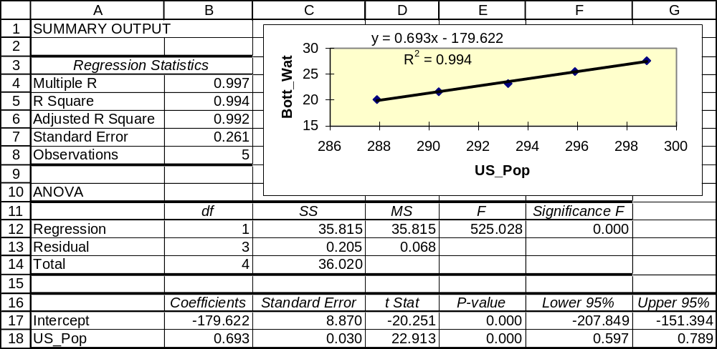

15.39 p/a/m
a. The least-squares equation for predicting the percentage of males who are overweight based on
average calories consumed per day is shown in the Minitab printout below. We have also specified
point and interval estimates based on 3000 calories consumed per day.

Regression Analysis: %_OverWt versus Calories/Day

The regression equation is %_OverWt = - 82.2 + 0.0424 Calories/Day

Predictor Coef SE Coef T P
Constant -82.19 20.65 -3.98 0.007
Calories/Day 0.042361 0.006801 6.23 0.001

S = 9.72415 R-Sq = 86.6% R-Sq(adj) = 84.4%

Analysis of Variance
Source DF SS MS F P
Regression 1 3668.4 3668.4 38.79 0.001
Residual Error 6 567.4 94.6
Total 7 4235.7

Predicted Values for New Observations
New
Obs Fit SE Fit 95% CI 95% PI
1 44.89 3.44 (36.48, 53.31) (19.66, 70.13)

Values of Predictors for New Observations
New
Obs Calories/Day
1 3000

b. The slope of the equation is positive, so r is the positive square root of r² = 0.866, or r = 0.931.
Because the slope is positive, higher levels of daily calorie consumption are associated with higher percentages of males who are overweight. The coefficient of determination, r², tells us that 86.6% of the variation in percentage of males who are overweight is explained by variation in the daily number of calories consumed.

c. For a country in which males consume 3000 calories per day, the equation would estimate that 44.89%
of the males in that country would be overweight. See the “Fit” column in the printout.

15.40 p/c/m The Minitab and Excel printouts are shown below.

Correlations: AcresBurned, RainInches

Pearson correlation of AcresBurned and RainInches = -0.233
P-Value = 0.445

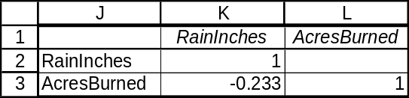

The coefficient of correlation is r = -0.233. The coefficient of determination is r² = (-0.233)² = 0.054.
The amount of rainfall explains only 5.4% of the variation in burned acreage.

15.41 p/c/m The Minitab and Excel printouts are shown below.

Correlations: gross_revenue, partners

Pearson correlation of gross_revenue and partners = 0.800
P-Value = 0.000

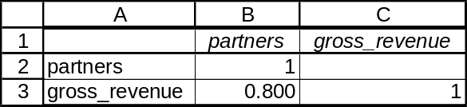

The coefficient of correlation is r = 0.800. Because it is positive, the variables are directly related.
The coefficient of determination is r² = (0.800)² = 0.640, so variation in the number of equity partners explains 64.0% of the variation in gross revenues.

15.42 p/c/m The Minitab and Excel printouts are shown below.

Correlations: US Price, Canada Price

Pearson correlation of US Price and Canada Price = 0.998
P-Value = 0.000

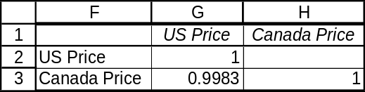

The coefficient of correlation is r = 0.9983. Because it is positive, the variables are directly related.
The coefficient of determination is r² = (0.9983)² = 0.9966. Price in the U.S. explains 99.66% of the variation in Canadian price.

15.43 p/c/m The Minitab and Excel printouts for the coefficient of correlation are shown below.

Correlations: DomGross, ForGross

Pearson correlation of DomGross and ForGross = 0.736
P-Value = 0.000

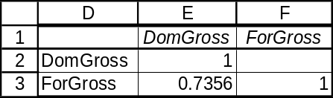

The coefficient of correlation is r = 0.7356. The coefficient of determination is r² = 0.7356² = 0.5411. Domestic gross explains 54.11% of the variation in foreign gross.

To the number of decimal places shown in the Excel printout, the regression equation is
ForGross = - 69.382 + 1.5266*DomGross. The Minitab and Excel printouts are shown below.

Regression Analysis: ForGross versus DomGross

The regression equation is ForGross = - 69 + 1.53 DomGross

Predictor Coef SE Coef T P
Constant -69.4 105.2 -0.66 0.518
DomGross 1.5266 0.3314 4.61 0.000

S = 152.5 R-Sq = 54.1% R-Sq(adj) = 51.6%

Analysis of Variance
Source DF SS MS F P
Regression 1 493846 493846 21.23 0.000
Residual Error 18 418805 23267
Total 19 912651

Unusual Observations
Obs DomGross ForGross Fit SE Fit Residual St Resid
1 601 1233.4 847.8 105.3 385.6 3.49RX
5 461 324.7 634.4 63.3 -309.7 -2.23R

R denotes an observation with a large standardized residual
X denotes an observation whose X value gives it large influence.

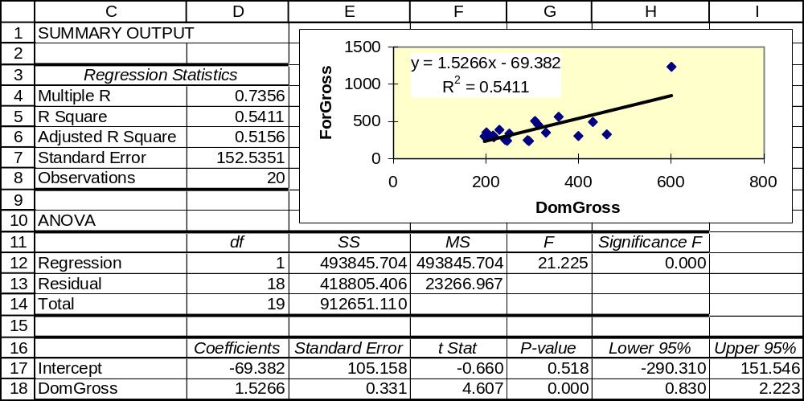

15.44 d/p/e If the slope of the true regression line is zero, then the true coefficient of correlation is also zero. Both of these cases imply no linear relationship between the dependent variable (y) and the independent variable (x).

15.45 c/a/m This calls for a hypothesis test with H₀: ρ = 0 (there is no linear relationship) and H₁: ρ ≠ 0 (there is a linear relationship). This is a two-tail t-test with α = 0.05 and d.f. = 15 - 2 = 13. The critical values of t are -2.160 and +2.160. The calculated value of the test statistic is:
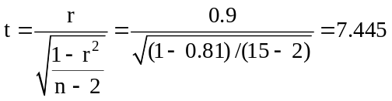
Since the calculated test statistic falls outside the critical values, we reject H₀. There is evidence to suggest that a linear relationship exists between x and y.

15.46 c/a/m This calls for the following hypothesis test:
H₀: ρ = 0 (there is no linear relationship) and H₁: ρ ≠ 0 (there is a linear relationship)
This is a two-tail t-test with α = 0.02 and d.f. = 37 - 2 = 35. The critical values of t are -2.438 and +2.438. The calculated value of the test statistic is:
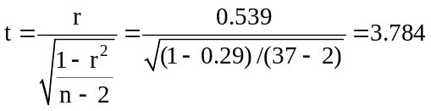
Since the calculated test statistic falls outside the critical values, we reject H₀. There is evidence to suggest that a linear relationship exists between x and y.

15.47 d/p/d At the 0.10 level of significance, we would not reject the null hypothesis that the true slope is equal to zero. This implies that the p-value is greater than 0.10. Since the 90% confidence interval contains 0, the p-value must be greater than 1 - 0.90; that is, it must be greater than 0.10.

15.48 d/p/d At the 0.05 level of significance, we would reject the null hypothesis that the true slope is equal to zero. This implies that the p-value is less than 0.05. Since the 95% confidence interval does not contain 0, the p-value must be less than 1 - 0.95; that is, it must be less than 0.05.

15.49 p/a/m Referring to the printouts shown in the solution to exercise 15.37, r = 0.860 and the slope of the regression equation is b₁ = 0.9551.

a. For testing the coefficient of correlation, the null and alternative hypotheses are:
H₀: ρ = 0 (there is no linear relationship) and H₁: ρ ≠ 0 (there is a linear relationship)
In the computer printout, the p-value for the two-tail test of the coefficient of correlation is (to three decimal places) 0.000. Since p-value = 0.000 is < α = 0.05 level of significance for the test, we reject H₀. At this level, the coefficient of correlation differs significantly from zero.

b. The null and alternative hypotheses are H₀: β₁ = 0 and H₁: β₁ ≠ 0. In the computer printouts shown in exercise 15.37, the p-value for the two-tail test of the slope of the regression equation is (to three decimal places) 0.000. Since p-value = 0.000 is < α = 0.05 level of significance for the test, we reject the null hypothesis that the population slope (β₁) could be zero.

c. As shown in the printouts in exercise 15.37, the standard deviation of the slope is 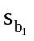 = 0.1791.
With d.f. = 12 - 2 = 10, the 95% confidence interval for the slope of the population regression line is:
b₁ ± t = 0.9551 ± 2.228(0.1791), or from 0.556 to 1.354.

Minitab does not directly provide any confidence interval for the slope of the population regression line, but a confidence interval can be obtained by using the appropriate value of t, along with the sample slope and the standard deviation of the slope, as shown in the preceding calculation.
Excel does provide lower and upper confidence limits for the population slope (β₁). The default is a 95% confidence interval. For the regression line in this exercise, Excel's 95% confidence interval for the slope is shown as 0.556 to 1.354. Refer to the Excel printout and cells F18:G18 in the solution for Exercise 15.37.

15.50 p/a/m Referring to the printouts shown in the solution to exercise 15.38, r = 0.997 and the slope of the regression equation is b₁ = 0.693.

a. For testing the coefficient of correlation, the null and alternative hypotheses are:
H₀: ρ = 0 (there is no linear relationship) and H₁: ρ ≠ 0 (there is a linear relationship)
In the computer printout, the p-value for the two-tail test of the coefficient of correlation is (to three decimal places) 0.000. Since p-value = 0.000 is < α = 0.05 level of significance for the test, we reject H₀. At this level, the coefficient of correlation differs significantly from zero.

b. The null and alternative hypotheses are H₀: β₁ = 0 and H₁: β₁ ≠ 0. In the computer printouts shown in exercise 15.38, the p-value for the two-tail test of the slope of the regression equation is (to three decimal places) 0.000. Since p-value = 0.000 is < α = 0.05 level of significance for the test, we reject the null hypothesis that the population slope (β₁) could be zero.

c. As shown in the printouts in exercise 15.38, the standard deviation of the slope is = 0.03025.
With d.f. = 5 - 2 = 3, the 95% confidence interval for the slope of the population regression line is:
b₁ ± t = 0.693 ± 3.182(0.03025), or from 0.597 to 0.789.

Minitab does not directly provide any confidence interval for the slope of the population regression line, but a confidence interval can be obtained by using the appropriate value of t, along with the sample slope and the standard deviation of the slope, as shown in the preceding calculation.
Excel does provide lower and upper confidence limits for the population slope (β₁). The default is a 95% confidence interval. For the regression line in this exercise, Excel's 95% confidence interval for the slope is shown as 0.597 to 0.789. Refer to the Excel printout and cells F18:G18 in the solution for Exercise 15.38.

15.51 c/a/m
a. We can use this hypothesis test:
H₀: β₁ = 0 (the true slope is 0) and H₁: β₁ ≠ 0 (the true slope is not zero)
This is a two-tail t-test with alpha = 0.05 and d.f. = 30 - 2 = 28. For the 0.05 level, the critical values of t are t = -2.048 and t = +2.048. The calculated value of the test statistic is:
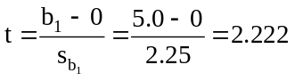
Since the calculated value of the test statistic falls outside the critical values, we reject H₀. There is evidence to suggest that there is a linear relationship between the x and y values.
b. Since we rejected the null hypothesis (of no linear relationship) in testing the slope of the regression equation, we will also reject the null hypothesis at the same level of significance in testing the coefficient of correlation. Testing either one of these is equivalent to testing both.
c. The 95% confidence interval for the true slope of the regression line is:
b₁ ± t = 5.0 ± 2.048(2.25) = 5.0 ± 4.608, or from 0.392 to 9.608

15.52 d/p/m Analysis of variance is yet another way to examine how much of the total variation in y (SST) is explained by the regression line (SSR). The ANOVA test is equivalent to those for the coefficient of correlation and the slope. The test is based on sum-of-squares values SST, SSR, and SSE, adjusted for the degrees of freedom for a particular regression. We reject the null hypothesis of no linear relationship between x and y if the calculated F value is larger than the critical F.

15.53 c/a/e We know that the coefficient of determination is r² = 1 - (SSE/SST).
Therefore: 0.49 = 1 - (SSE/120), 0.51 = SSE/120, and SSE = 61.2
Since SSE = 61.2, SSR must be 58.8. (SST = SSR + SSE.)

15.54 c/a/e We know that the coefficient of determination is r² = 1 - (SSE/SST). Therefore the coefficient of determination is 1 - (40.0/200.0) = 0.80.

15.55 c/a/m The table below details the calculations for SSE and SST.
Recall that SSR = SST - SSE. The regression equation is = 20.66 + 4.02x, and the mean of the y values is = 51.2.
x | y |  |  |  | 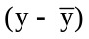 | 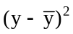
5 | 34 | 40.76 | -6.76 | 45.6976 | -17.2 | 295.84
4 | 44 | 36.74 | 7.26 | 52.7076 | -7.2 | 51.84
10 | 65 | 60.86 | 4.14 | 17.1396 | 13.8 | 190.44
9 | 47 | 56.84 | -9.84 | 96.8256 | -4.2 | 17.64
10 | 66 | 60.86 | 5.14 | 26.4196 | 14.8 | 219.04
 |  |  |  | sum = 238.7900 |  | sum = 774.80

SST = 774.80 and SSE = 238.79.
Therefore, SSR = SST - SSE = 536.01 and r² = 536.01/774.80 = 0.692.
The appropriate null and alternative hypotheses are:
H₀: There is no linear relationship between x and y, and H₁: There is a linear relationship

The F statistic will have 1 and 3 degrees of freedom. For α = 0.05 level of significance, the critical value of F is 10.13. The calculated value of F is: 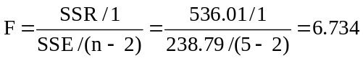

Since the calculated F does not exceed the critical value, we do not reject H₀. At this level, there is no evidence to suggest that a linear relationship exists between x and y. Therefore, we cannot say that r² is significantly different from 0.

15.56 c/a/m The table below details the calculations for SST and SSE.
Recall that SSR = SST - SSE. The regression equation is = 404.94 - 3.78x, and the mean of the y values is = 390.75.
x | y
4 | 381 | 389.82 | -8.82 | 77.7924 | -9.75 | 95.0625
1 | 403 | 401.16 | 1.84 | 3.3856 | 12.25 | 150.0625
4 | 394 | 389.82 | 4.18 | 17.4724 | 3.25 | 10.5625
6 | 385 | 382.26 | 2.74 | 7.5076 | -5.75 | 33.0625
 |  |  |  | sum = 106.1580 |  | sum = 288.7500

SST = 288.75 and SSE = 106.158.
Therefore SSR = SST - SSR = 182.592, and r² = 182.592/288.75 = 0.632.
The appropriate null and alternative hypotheses are:
H₀: There is no linear relationship between x and y, and H₁: there is a linear relationship
The F statistic will have 1 and 2 degrees of freedom. For α = 0.05 level of significance, the critical value of F is 18.51. The calculated value of F is: 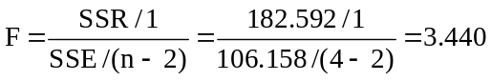

Since the calculated F does not exceed the critical value, we do not reject H₀. At this level, there is no evidence to suggest that a linear relationship exists between x and y. Therefore, we cannot say that r² is significantly different from 0.

15.57 p/c/m The Minitab and Excel printouts are shown below.

Regression Analysis: Gallons versus Hours

The regression equation is Gallons = 5921561 + 10.4 Hours

Predictor Coef SE Coef T P
Constant 5921561 10790160 0.55 0.612
Hours 10.4481 0.6132 17.04 0.000

S = 1056418 R-Sq = 98.6% R-Sq(adj) = 98.3%

Analysis of Variance
Source DF SS MS F P
Regression 1 3.24029E+14 3.24029E+14 290.34 0.000
Residual Error 4 4.46408E+12 1.11602E+12
Total 5 3.28493E+14

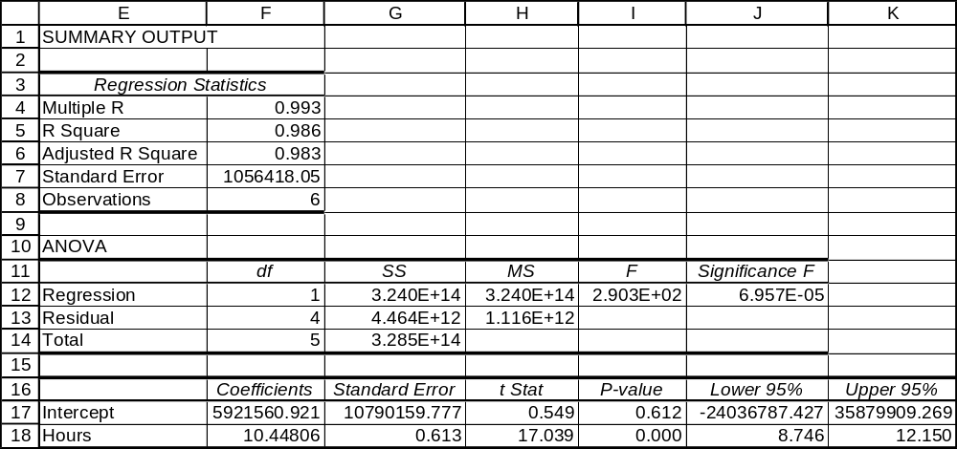

The regression equation is Gallons = 5921560.92 + 10.44806*Hours.
The slope is 10.44806 -- on average, one additional hour of flying time will require 10.44806 additional gallons of fuel. The coefficients of correlation and determination are 0.993 and 0.986, respectively.
The flying hours variable explains 98.6% of the variation in fuel consumed. To three decimal places,
the p-value is 0.000, and this is less than 0.05. At this level of significance, the population slope and the population coefficient of correlation could not be zero. The lower and upper 95% confidence limits for the population slope are 8.746 and 12.150, respectively.

15.58 p/c/m The Minitab and Excel printouts are shown below.

Regression Analysis: AcresBurned versus RainInches

The regression equation is AcresBurned = 349550 - 7851 RainInches

Predictor Coef SE Coef T P
Constant 349550 179579 1.95 0.078
RainInch -7851 9902 -0.79 0.445

S = 185098 R-Sq = 5.4% R-Sq(adj) = 0.0%

Analysis of Variance
Source DF SS MS F P
Regression 1 21539746092 21539746092 0.63 0.445
Residual Error 11 3.76873E+11 34261159213
Total 12 3.98412E+11

Unusual Observations
Obs RainInch AcresBur Fit SE Fit Residual St Resid
2 12.1 645331 254861 73546 390470 2.30R
4 30.1 86948 113142 136122 -26194 -0.21 X

R denotes an observation with a large standardized residual
X denotes an observation whose X value gives it large influence.

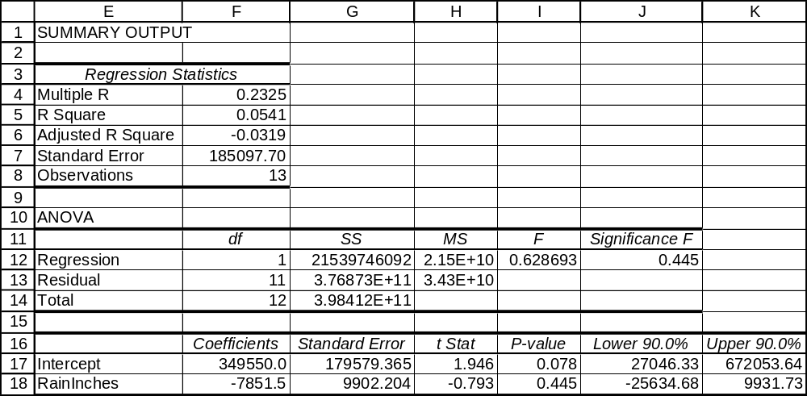

The regression equation is AcresBurned = 349,550 - 7851.5*RainInches.
The slope is 7851.5 -- on average, each additional inch of rain will be accompanied by 7851.5 fewer acres burned. The coefficients of correlation and determination are 0.2325 and 0.0541, respectively.
The amount of rainfall explains 5.41% of the variation in acreage burned. The p-value is 0.445, which is not less than 0.10. At the 0.10 level of significance, the population slope and the population coefficient of correlation could be zero. The lower and upper 90% confidence limits for the population slope are
-25,634.68 and 9931.73, respectively.

15.59 p/c/m The Minitab and Excel printouts are shown below.

Regression Analysis: Net Income versus Revenue

The regression equation is Net Income = 59.8 + 0.0382 Revenue
Predictor Coef SE Coef T P
Constant 59.80 21.23 2.82 0.006
Revenue 0.038208 0.003413 11.20 0.000

S = 201.3 R-Sq = 56.1% R-Sq(adj) = 55.7%

Analysis of Variance
Source DF SS MS F P
Regression 1 5078439 5078439 125.36 0.000
Residual Error 98 3970099 40511
Total 99 9048539

Unusual Observations
Obs Revenue Net Inco Fit SE Fit Residual St Resid
29 45625 1109.0 1803.0 150.3 -694.0 -5.18RX
48 27008 1757.0 1091.7 87.8 665.3 3.67RX
50 3621 667.6 198.1 20.9 469.5 2.35R
59 7055 1120.2 329.4 26.6 790.8 3.96R
76 16894 1825.3 705.3 54.7 1120.0 5.78RX
86 20779 265.1 853.7 67.2 -588.6 -3.10RX
95 2489 577.0 154.9 20.2 422.1 2.11R

R denotes an observation with a large standardized residual
X denotes an observation whose X value gives it large influence.

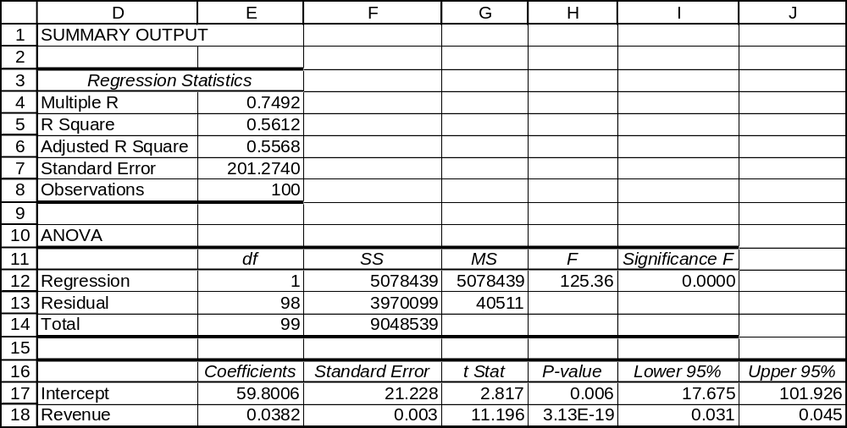

The regression equation is Net Income = 59.8006 + 0.0382*Revenue.
The slope is 0.0382 -- on average, each additional dollar of revenue is accompanied by an additional $0.0382 in net income. The coefficients of correlation and determination are 0.7492 and 0.5612, respectively. The amount of revenue explains 56.12% of the variation in net income. To four decimal places, the p-value is 0.0000, which is less than 0.05. At the 0.05 level of significance, the population slope and the population coefficient of correlation could not be zero. The lower and upper 95% confidence limits for the population slope are 0.031 and 0.045, respectively.

15.60 d/p/m For any given x value, the residual is simply the observed value of y minus the value that would be predicted by the regression equation.

15.61 d/p/m Residual analysis refers to a broad class of tests which can be performed using the error terms from a regression line to test the assumptions of regression analysis. Residual analysis can test the assumption of normal distribution of the error terms, the assumption of equal standard deviations of the error terms, and the assumption that the error terms are independent from one another.
In residual analysis, we may also “flag” error values that are especially large.

15.62 d/p/m Spurious correlation occurs whenever two variables are highly correlated but there is little evidence to suggest any causation. For instance, the closing of the Dow Jones Industrial Average (DJIA) could be highly correlated with the winner of the Super Bowl. (When the NFC wins it has historically tended to close higher for the year, and when the AFC wins it has tended to close lower for the year.) However, there is no evidence to suggest that the Super Bowl winning conference causes the DJIA to move up or down. Likewise, there is no evidence to suggest that the movement in the DJIA causes one conference or the other to win the Super Bowl.

15.63 d/p/d Correlation does not necessarily imply causation of any kind. Perhaps sales have increased as a result of better products which came from more money invested in research and development. On the other hand, perhaps the R&D budget is set based on past or anticipated sales.
It is also very possible that both of these variables have simply increased over time.

15.64 d/p/m It can be very dangerous to extrapolate regression equations beyond the limits of the x data. The x data in this case cover the years 1957 through 1959 only. It is unwise to extrapolate this out to 2006. (This is actually extending the data more than fifteen times the period it covers. It covers three years, and the speaker is extending it 47 years into the future.)

15.65 c/c/m We will use Minitab to obtain the regression equation and to analyze the residuals.
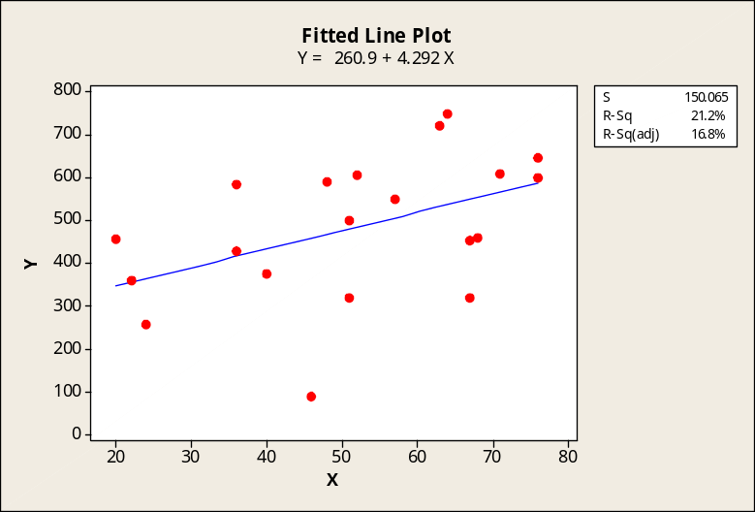

a. The histogram of residuals looks fairly normal.
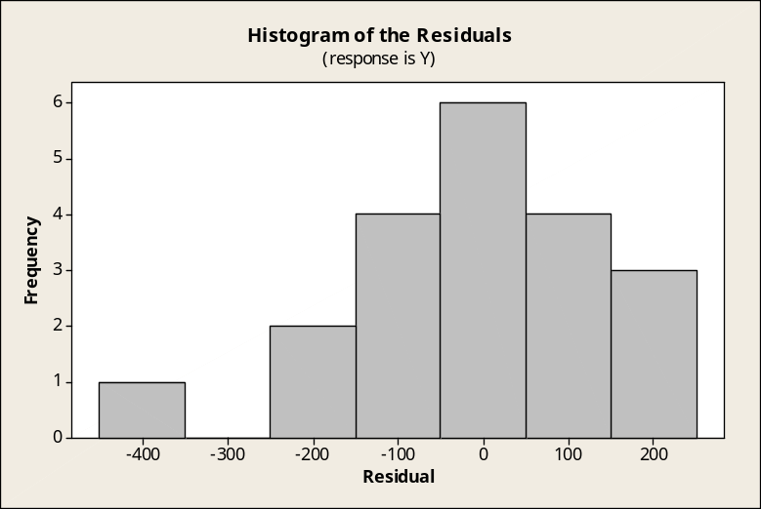

b. The normal probability plot as carried out by the Minitab normality test. The approximate p-value
is > 0.15. At the 0.05 level of significance, we would conclude that the residuals could have come from a normal population.
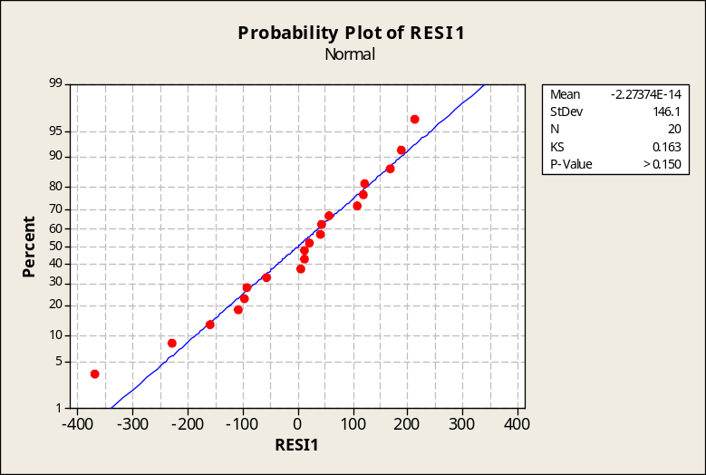

c. Plot of residuals versus the x values. The residuals appear to be relatively randomly scattered above and below the “0” line.
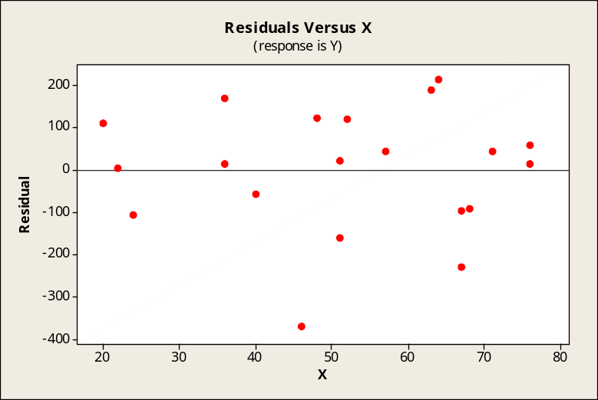

d. Plot of residuals versus the order of the data. Six of the first 8 residuals are positive, 4 of the next 6 are negative, and 5 of the last 6 are positive. There may be a nonrandom pattern here.
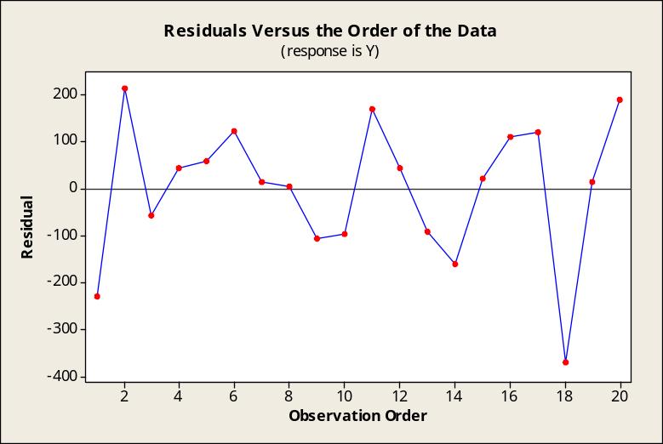

15.66 c/c/m We will use Minitab to obtain the regression equation and to analyze the residuals.
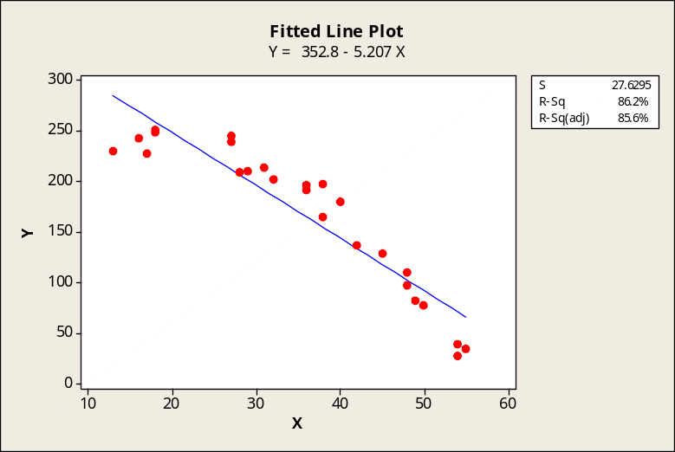

a. The histogram of residuals is somewhat symmetric but may not be normal. However, this is based on visual examination and judgement, so we will rely on the Minitab test for normality in part (b).
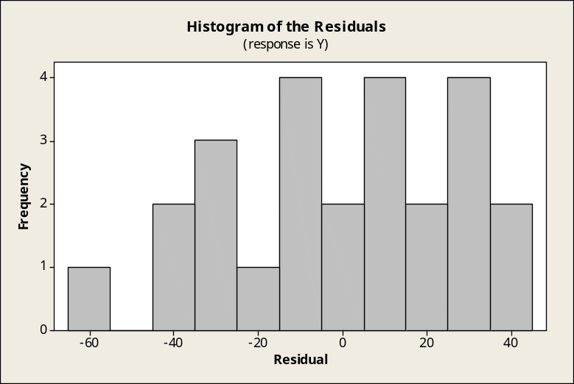

b. The normal probability plot as carried out by the Minitab normality test. The approximate p-value
is > 0.15. At the 0.05 level of significance, we would conclude that the residuals could have come from a normal population.
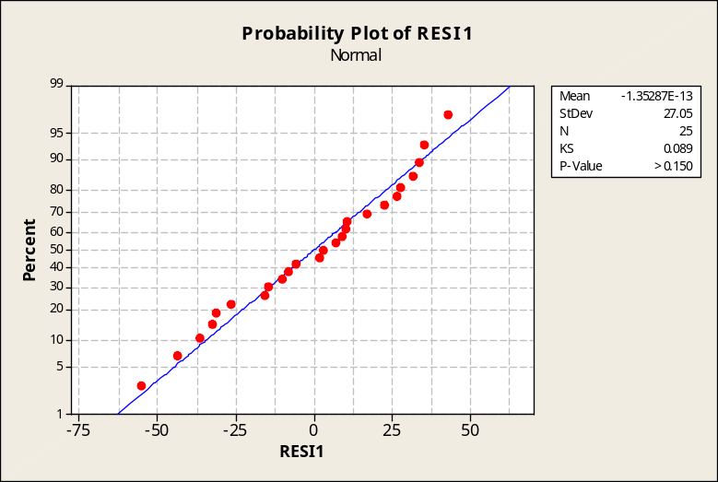

c. Plot of residuals versus the x values. The points in this plot seem to be arranged in an upside-down “U” shape, indicating a relationship between the value of x and the value of the residual.
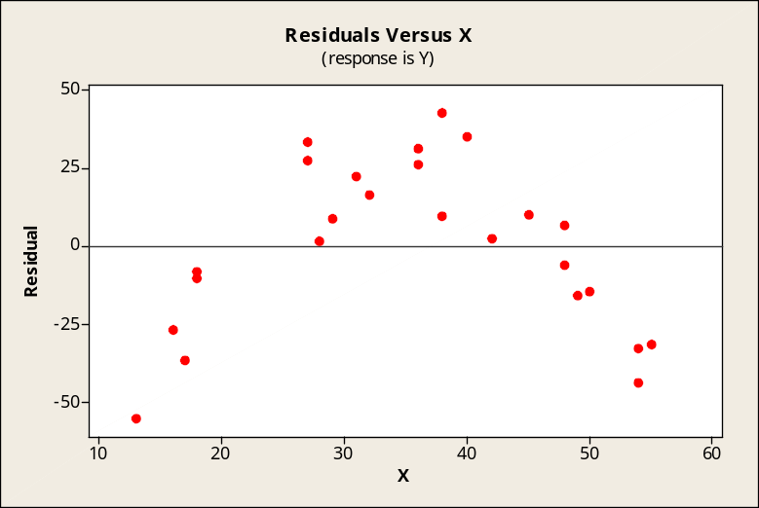

d. Plot of residuals versus the order of the data. The sequence of residuals appears to be random.
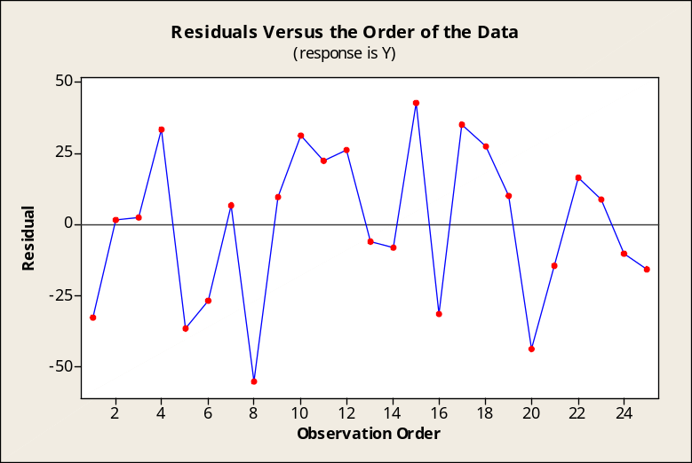

15.67 p/c/m We will use Minitab to obtain the regression equation and to analyze the residuals. In the scatter diagram below, it would appear that none of the years was associated with especially high or low fuel consumption for the number of flying hours during the year.
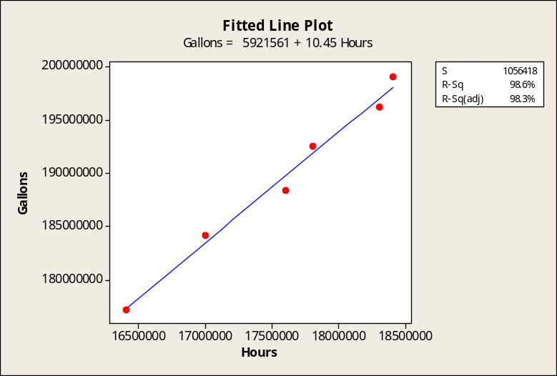

a. The histogram of residuals does not appear normal. However, this is based on visual examination and judgement, so we will rely on the Minitab test for normality in part (b).
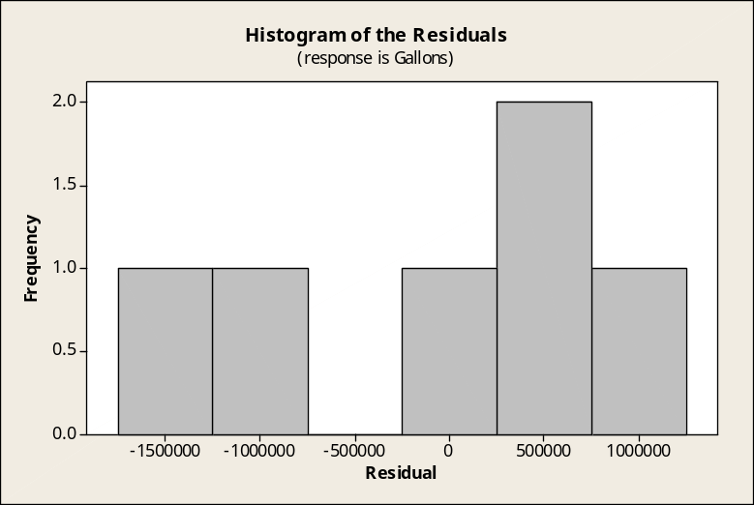

b. The normal probability plot as carried out by the Minitab normality test. The approximate p-value
is > 0.15. At the 0.05 level of significance, we would conclude that the residuals could have come from a normal population.
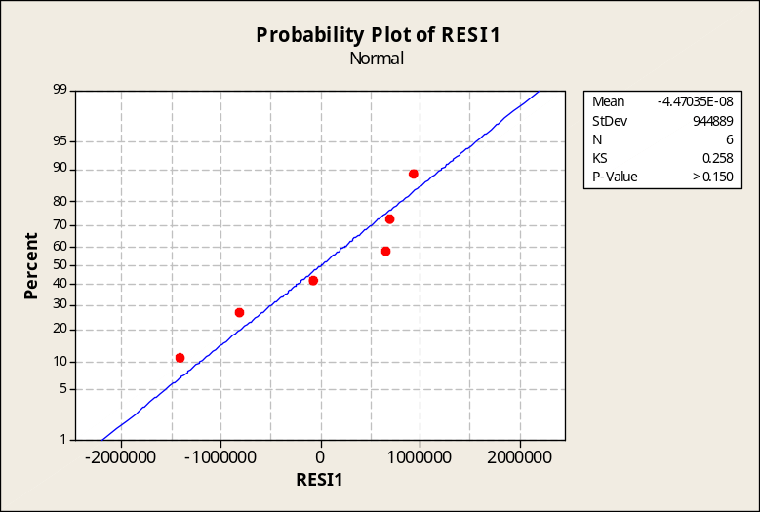

c. Plot of residuals versus the x values. The points in this plot seem to be rather random.
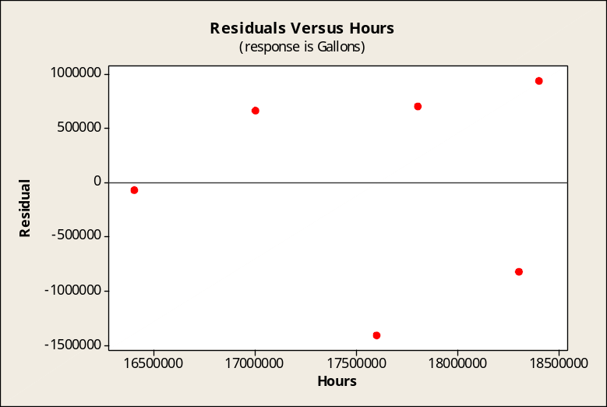

d. Plot of residuals versus the order of the data. There seems to be a downward tendency, but the number of points is very small.
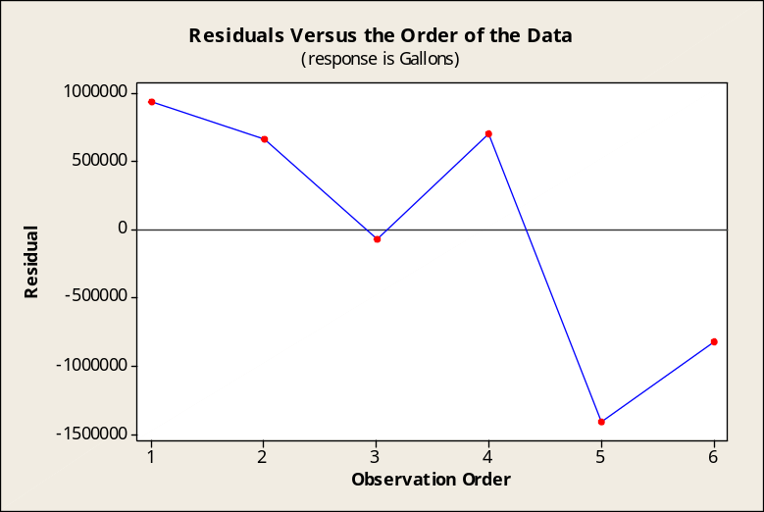

15.68 p/c/m We will use Minitab to obtain the regression equation and to analyze the residuals. In the scatter diagram below, it would appear that several of the companies have a net income that is either very high or very low for their amount of revenue.
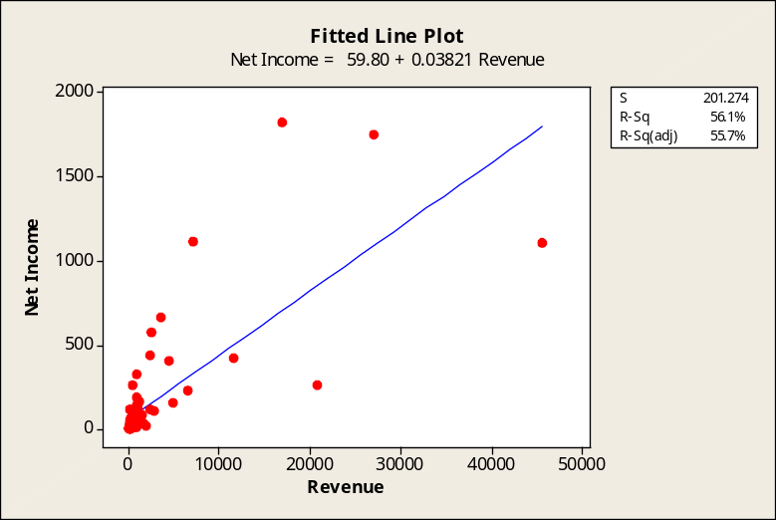

a. From this default histogram, it is difficult to assess whether the population could be normal, so we will rely on the Minitab test for normality in part (b).
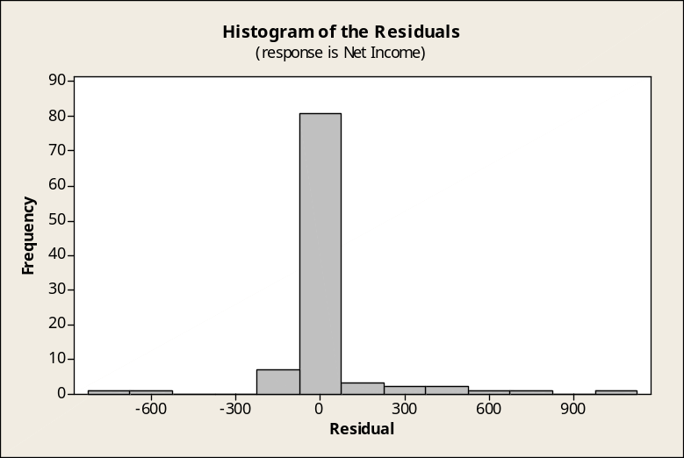

b. The normal probability plot as carried out by the Minitab normality test. The approximate p-value
is < 0.010. At the 0.05 level of significance, we would conclude that the residuals did not come from a normal population.
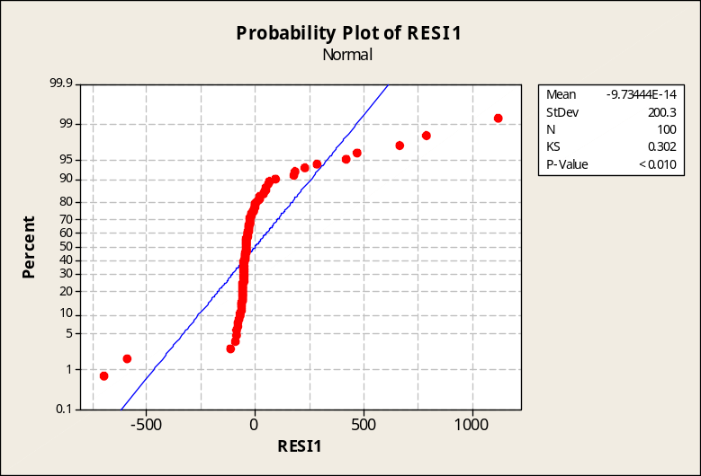

c. Plot of residuals versus the x values. As revenue increases, the residuals tend to be more distant from the “0” line.
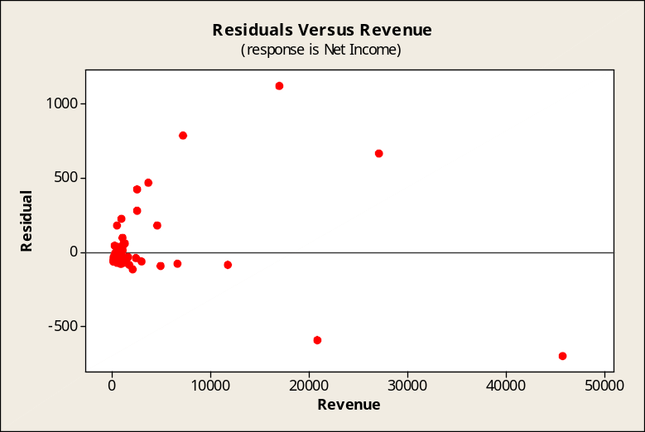

d. Plot of residuals versus the order of the data. The latter half of the order seems to have a lot of large, positive residuals.
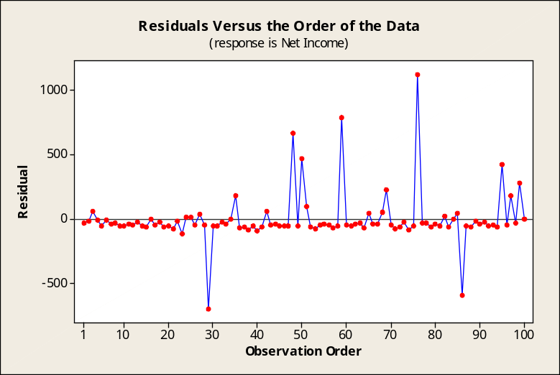

CHAPTER EXERCISES
15.69 d/p/m
a. The monthly mortgage payment would likely be directly related to the market value of the house,
the interest rate, the size of the house, or the monthly taxes and insurance, among other variables.
b. The monthly mortgage payment would likely be inversely related to the age of the house,
among other variables.
c. The monthly mortgage payment would likely be unrelated to the amount of chocolate consumed by the owners, and a wide variety of other variables.

15.70 d/p/m A personal variable that might be directly related to freshman grade point average is high
school grade point average. A personal variable that might be inversely related to freshman grade point average is number of times arrested during high school.

15.71 p/a/m The least-squares equation is NetIncome = 0.211 + 0.0999*TotRev. For each additional $billion of total revenue, the equation would estimate an increase of $0.0999 billion in the company’s net income. Note that the p-value is not very impressive, 0.174, and the slope of the population regression equation could very easily be 0, at least based on this sample of years. For a year in which total revenues are $18 billion, the equation would estimate net income as $2.009 billion. The Minitab printout is shown below.

Regression Analysis: NetIncome versus TotRev

The regression equation is NetIncome = 0.21 + 0.0999 TotRev

Predictor Coef SE Coef T P
Constant 0.211 1.041 0.20 0.846
TotRev 0.09990 0.06475 1.54 0.174

S = 0.482407 R-Sq = 28.4% R-Sq(adj) = 16.5%

Analysis of Variance
Source DF SS MS F P
Regression 1 0.5539 0.5539 2.38 0.174
Residual Error 6 1.3963 0.2327
Total 7 1.9502

Predicted Values for New Observations
New
Obs Fit SE Fit 95% CI 95% PI
1 2.009 0.220 (1.471, 2.547) (0.712, 3.306)

Values of Predictors for New Observations
New
Obs TotRev
1 18.0

15.72 p/a/m The Excel regression equation and plot are shown below.
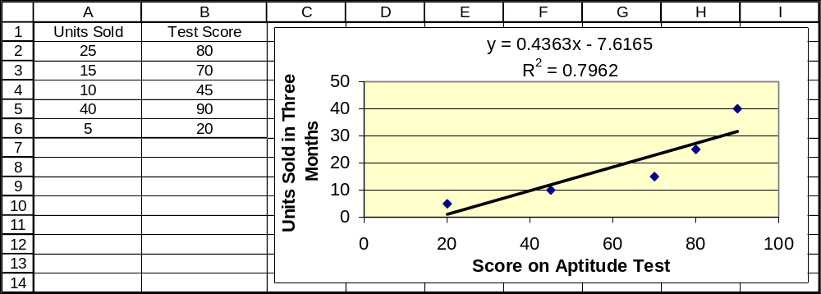
There appears to be a direct, curvilinear relationship between these variables. That is, the sales volume increases with an increase in the score on the aptitude test, and the slope seems to be increasing as the score increases. For the linear regression equation, the slope is 0.4363 -- on average, each additional point on the aptitude test is accompanied by 0.4363 additional units in sales. The estimate for a person scoring 60 on the test would be -7.6165 + 0.4363(60) = 18.56 units.

15.73 p/a/m
a. The least squares equation and slope interpretation. On average, for each 1 percentage point increase
in the 3-year annualized rate of return, the estimate for the 1-year rate of return would increase by 1.45
percentage points.

Regression Analysis: 1yr_% versus 3yr_%/yr

The regression equation is 1yr_% = - 2.01 + 1.45 3yr_%/yr

Predictor Coef SE Coef T P
Constant -2.0065 0.5829 -3.44 0.041
3yr_%/yr 1.45411 0.09351 15.55 0.001

S = 0.382033 R-Sq = 98.8% R-Sq(adj) = 98.4%

Analysis of Variance
Source DF SS MS F P
Regression 1 35.294 35.294 241.82 0.001
Residual Error 3 0.438 0.146
Total 4 35.732

Predicted Values for New Observations
New
Obs Fit SE Fit 95% CI 95% PI
1 5.264 0.193 (4.650, 5.878) (3.902, 6.626)

Values of Predictors for New Observations
New
Obs 3yr_%/yr
1 5.00

b. As shown in the Minitab printout in part (a), the 1-year rate of return would be estimated as 5.264%
if the 3-year annualized rate of return is 5.0%.

c. As shown in the partial Minitab printout below, the 1-year rate of return would be estimated
as 8.172% if the 3-year annualized rate of return is 7.0%.

Regression Analysis: 1yr_% versus 3yr_%/yr

The regression equation is 1yr_% = - 2.01 + 1.45 3yr_%/yr

Predictor Coef SE Coef T P
Constant -2.0065 0.5829 -3.44 0.041
3yr_%/yr 1.45411 0.09351 15.55 0.001

...
...

Predicted Values for New Observations
New
Obs Fit SE Fit 95% CI 95% PI
1 8.172 0.197 (7.547, 8.798) (6.805, 9.540)

Values of Predictors for New Observations
New
Obs 3yr_%/yr
1 7.00

15.74 p/a/m
The least squares regression analysis below is generated using Minitab:

Regression Analysis: Income versus OpRev

The regression equation is Income = 106 - 0.0074 OpRev

Predictor Coef SE Coef T P
Constant 105.89 31.29 3.38 0.043
OpRev -0.00743 0.01434 -0.52 0.640

S = 11.7834 R-Sq = 8.2% R-Sq(adj) = 0.0%

Analysis of Variance
Source DF SS MS F P
Regression 1 37.2 37.2 0.27 0.640
Residual Error 3 416.5 138.8
Total 4 453.8

Predicted Values for New Observations
New
Obs Fit SE Fit 95% CI 95% PI
1 87.32 7.28 (64.17, 110.48) (43.25, 131.40)

Values of Predictors for New Observations
New
Obs OpRev
1 2500

To the maximum number of decimal places shown in the printout, the regression equation is
Income = 105.89 - 0.00743*OpRev. Interpreting the slope, for every increase of $1 million in operating revenue, the company would be predicted to lose $0.00743 million in net income. The sign of the slope is the reverse of what we might expect, but the p-value = 0.640 for the test of the slope is very weak.

For a year in which x = $2500 million in operating revenue, the company would predict net income
as 105.89 - 0.00743(2500) = $87.32 million. See the "Fit" column in the Minitab printout.

The corresponding Excel printout and plot are shown below.
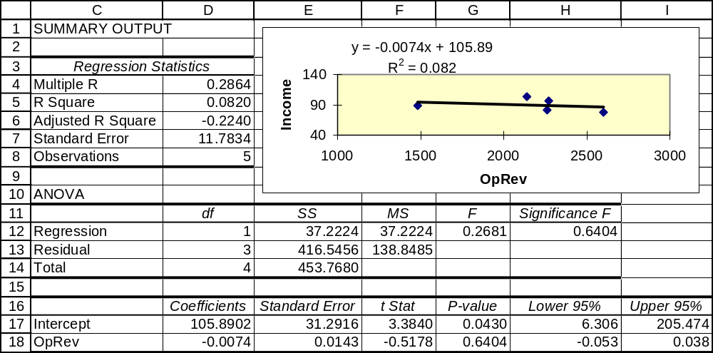

15.75 p/a/m
The Minitab least squares regression printout is shown below, with specification for point and interval estimates for net income when operating revenue is $30 billion.

Regression Analysis: net_income versus op_revenue

The regression equation is net_income = 2.30 + 0.116 op_revenue

Predictor Coef SE Coef T P
Constant 2.3014 0.7082 3.25 0.047
op_revenue 0.11626 0.02700 4.31 0.023

S = 0.231726 R-Sq = 86.1% R-Sq(adj) = 81.4%

Analysis of Variance
Source DF SS MS F P
Regression 1 0.99559 0.99559 18.54 0.023
Residual Error 3 0.16109 0.05370
Total 4 1.15668

Predicted Values for New Observations
New
Obs Fit SE Fit 95% CI 95% PI
1 5.789 0.151 (5.310, 6.269) (4.910, 6.669)

Values of Predictors for New Observations
New
Obs op_revenue
1 30.0

To the maximum number of decimal places shown in the printout, the regression equation is
net_income = 2.3014 + 0.11626*op_revenue. On average, for every increase of $1 billion in operating revenue, the company would anticipate an additional $0.11626 billion in net income. Alternatively, we might view each additional dollar of operating revenue as generating about $0.11626 in additional net income.
For a year in which x = $30 billion in operating revenue, the company would predict net income as
2.3014 + 0.11626*(30) = $5.789 billion. See the "Fit" column in the Minitab printout.

The corresponding Excel printout and plot are shown below.
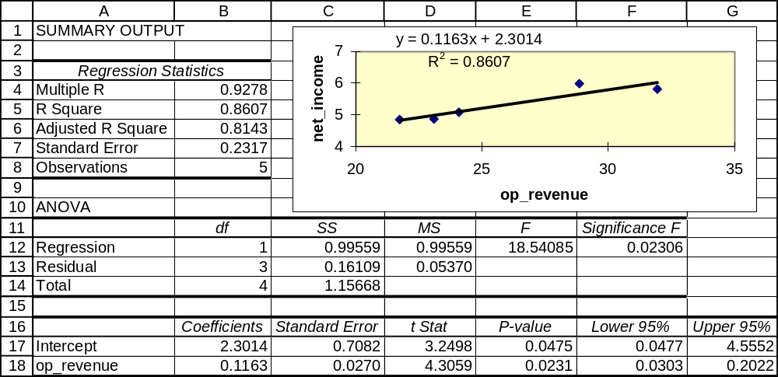

15.76 p/a/m
a. The Minitab least squares regression printout is shown below, with specification for point and interval
estimates for retail furniture store sales when there are 1.80 million housing starts in a year.

Regression Analysis: furniture versus h_starts

The regression equation is furniture = 23.5 + 20.5 h_starts

Predictor Coef SE Coef T P
Constant 23.548 6.222 3.78 0.032
h_starts 20.451 4.146 4.93 0.016

S = 1.51008 R-Sq = 89.0% R-Sq(adj) = 85.4%

Analysis of Variance
Source DF SS MS F P
Regression 1 55.491 55.491 24.33 0.016
Residual Error 3 6.841 2.280
Total 4 62.332

Predicted Values for New Observations
New
Obs Fit SE Fit 95% CI 95% PI
1 60.359 1.444 (55.762, 64.956) (53.708, 67.009)

Values of Predictors for New Observations
New
Obs h_starts
1 1.80

To the maximum number of decimal places shown in the printout, the regression equation is
furniture = 23.548 + 20.451*h_starts.

b. The coefficient of determination is r² = 0.890, and its positive (since the slope is positive) square root is r = 0.94. The coefficient of correlation is positive, indicating that the two variables tend to increase and decrease together. The coefficient of determination indicates that 89.0% of the variation in retail furniture store sales is explained by housing starts.

c. If there were 1.80 million housing starts in a given year, the estimate for the value of retail furniture store sales would be 23.548 + 20.451(1.80) = $60.359 billon. See the "Fit" column in the printout.

The corresponding Excel printout and plot are shown below.
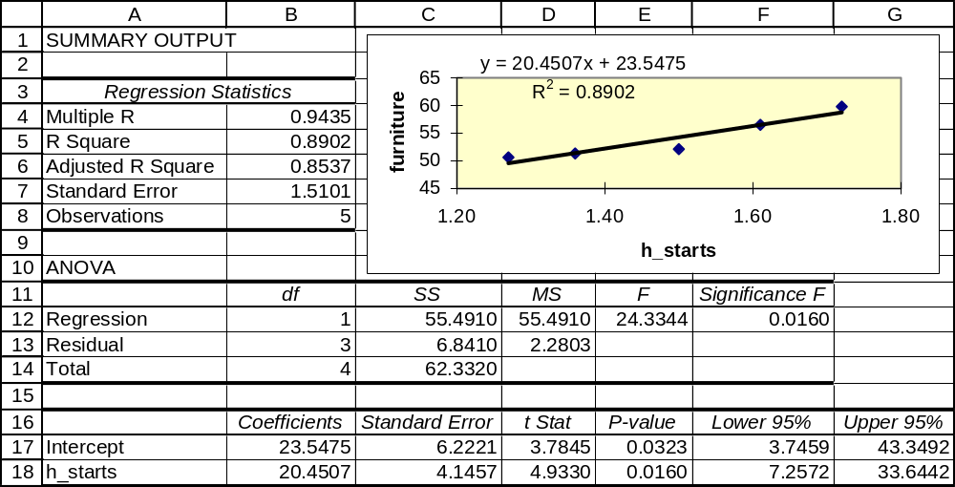
15.77 p/a/m
a. The Minitab least squares regression printout is shown below, with specification for point and interval
estimates for the total insurance face value amount when there are 30 million individual life insurance
policies.

Regression Analysis: amount versus policies

The regression equation is amount = - 2366 + 624 policies

Predictor Coef SE Coef T P
Constant -2366 1751 -1.35 0.269
policies 623.93 45.82 13.62 0.001

S = 1785.33 R-Sq = 98.4% R-Sq(adj) = 97.9%

Analysis of Variance
Source DF SS MS F P
Regression 1 590941735 590941735 185.40 0.001
Residual Error 3 9562200 3187400
Total 4 600503935

Predicted Values for New Observations
New
Obs Fit SE Fit 90% CI 90% PI
1 16352 819 (14424, 18280) (11729, 20975)

Values of Predictors for New Observations
New
Obs policies
1 30.0

To the maximum number of decimal places shown in the printout, the regression equation is
amount = -2366 + 623.93*policies. The slope indicates that, on average, each increase of 1 million in the number of policies is associated with an increase of $623.93 million in the total face value of life insurance policies. We might also view the slope as indicating that if 1 policy were to be added, the estimated total face value of all policies would increase by $623.93. This might seem very low, but keep in mind that a dollar went a very long way back in the early 1900s.

b. The coefficient of determination is r² = 0.984, and its positive (since the slope is positive) square root is r = 0.99. The coefficient of correlation is positive, indicating that the two variables tend to increase and decrease together. The coefficient of determination indicates that 98.4% of the variation in the total of policy face value amounts is explained by the number of policies.

c. During a year in which there are 30 million policies in force, the equation would estimate the total face value of these policies as -2366 + 623.93*(30) = $16352 million. See the "Fit" column in the Minitab printout.

The corresponding Excel printout and plot are shown below.
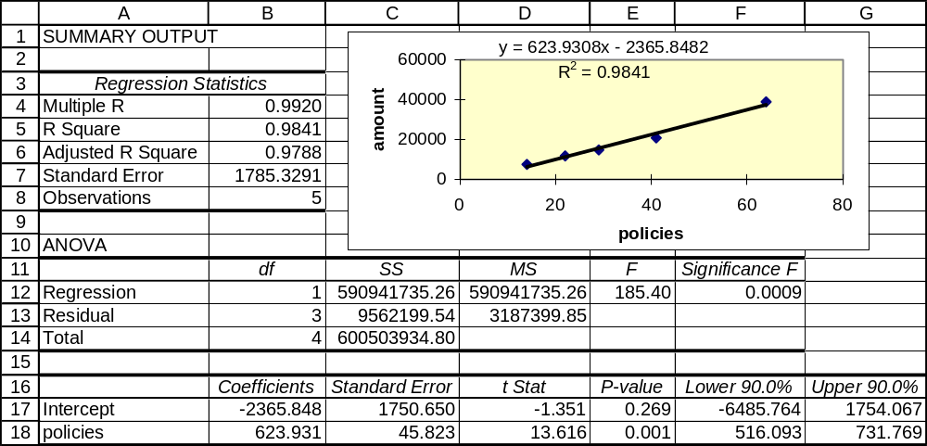

15.78 p/a/m
Referring to the printouts in the solution for Exercise 15.77:
a. Using the 0.10 level of significance to test whether the population coefficient of coefficient could be zero, the appropriate null and alternative hypotheses are H₀: ρ = 0 and H₁: ρ ≠ 0. The Minitab printout shows the p-value for this test as 0.001. Because p-value = 0.001 is < α = 0.10 level of significance, we reject the null hypothesis and conclude that the population coefficient of correlation is not zero.

b. The appropriate null and alternative hypotheses are H₀: β₁ = 0 and H₁: β₁ ≠ 0.
Minitab has already calculated the p-value for this test. To three decimal places, it is 0.001.
Since p-value = 0.001 is < α = 0.10 level of significance for the test, we reject H₀. There is very
strong evidence that the population regression coefficient is not zero.

c. The 90% confidence interval for the slope of the population regression equation can be calculated as
b₁ ± t= 623.93 ± 2.353(45.82) = 623.93 ± 107.81, or from 516.12 to 731.74. This interval does
not contain zero, nor did we expect it to. We have already determined that the population regression
slope is significantly different from zero at the 0.10 level. You may also refer to the "Hours" row and
the "Lower 90%" and "Upper 90%" columns of the Excel printout associated with exercise 15.77.
See cells F18:G18 for the more exact values, 516.09 to 731.77.

15.79 p/a/m The Minitab printout and least-squares equation are shown below.

Regression Analysis: fuel versus miles

The regression equation is fuel = 48.1 + 0.0422 miles

Predictor Coef SE Coef T P
Constant 48.065 9.067 5.30 0.013
miles 0.042244 0.003081 13.71 0.001

S = 0.413511 R-Sq = 98.4% R-Sq(adj) = 97.9%

Analysis of Variance
Source DF SS MS F P
Regression 1 32.155 32.155 188.05 0.001
Residual Error 3 0.513 0.171
Total 4 32.668

Predicted Values for New Observations
New
Obs Fit SE Fit 95% CI 95% PI
1 179.021 0.518 (177.371, 180.670) (176.910, 181.131)X

X denotes a point that is an outlier in the predictors.

Values of Predictors for New Observations
New
Obs miles
1 3100

a. The regression equation is fuel = 48.065 + 0.042244*miles
b. The coefficient of correlation is the square root of 0.984, or 0.992. It is positive and indicates a direct
relationship between the variables. The coefficient of determination is 0.984, and the number of miles traveled explains 98.4% of the variation in fuel consumption.
c. If motor vehicle travel during a year were 3100 billion miles, the equation would predict a fuel
consumption level of 48.065 + 0.042244*(3100) = 179.02 billion gallons. Also see the “Fit” column
in the Minitab printout.

The corresponding Excel printout and plot are shown below.
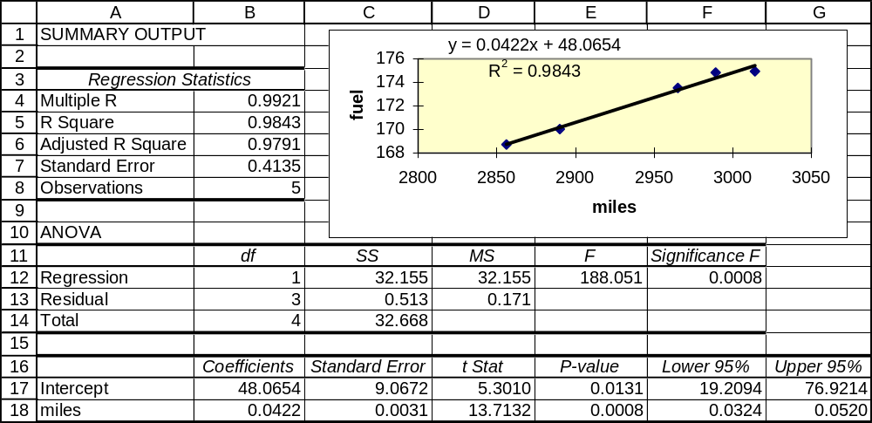

15.80 p/a/m
a. The appropriate null and alternative hypotheses are H₀: ρ = 0 and H₁: ρ ≠ 0.
This is a two-tail t-test at the α = 0.05 level and 5 - 2 = 3 degrees of freedom. The critical values of t are t = -3.182 and t = +3.182. To three decimal places, the Minitab printout in the solution to Exercise 15.79 reported r² = 0.984, or r = 0.992. The calculated value of the test statistic is:
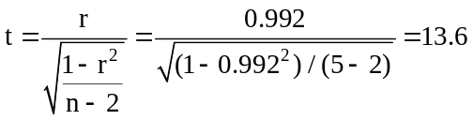

Due to rounding, our calculated test statistic loses a little accuracy, but it still greatly exceeds the upper critical value and we reject H₀. Referring to the printouts in Exercise 15.79, Minitab has already calculated the p-value for this test. To three decimal places, it is 0.001.
Since p-value = 0.001 is < α = 0.05 level of significance for the test, we reject H₀. There is very strong evidence that the population coefficient of correlation is not zero.

b. The appropriate null and alternative hypotheses are H₀: β₁ = 0 and H₁: β₁ ≠ 0.
Minitab has already calculated the p-value for this test. To three decimal places, it is 0.001.
Since p-value = 0.001 is < α = 0.05 level of significance for the test, we reject H₀. There is very strong evidence that the slope of the population regression equation is not zero.

c. The 95% confidence interval for the slope of the population regression equation is:
b₁ ± t= 0.042244 ± 3.182(0.003081) = 0.042244 ± 0.009804, or from 0.032 to 0.052. We can also
get this interval directly from the Excel printout in the solution to Exercise 15.79. See cells F18:G18.
This confidence interval does not contain zero, so we conclude that the population regression slope could not be zero.

15.81 d/p/m The Minitab printout and least-squares equation are shown below.

Regression Analysis: Rear_Full versus Rear_Corner

The regression equation is Rear_Full = 318 + 2.61 Rear_Corner

Predictor Coef SE Coef T P
Constant 318 1963 0.16 0.877
Rear_Corner 2.612 2.702 0.97 0.378

S = 1237.17 R-Sq = 15.7% R-Sq(adj) = 0.0%

Analysis of Variance
Source DF SS MS F P
Regression 1 1429525 1429525 0.93 0.378
Residual Error 5 7652890 1530578
Total 6 9082415

Predicted Values for New Observations
New
Obs Fit SE Fit 90% CI 90% PI
1 2408 533 (1334, 3481) (-306, 5122)

Values of Predictors for New Observations
New
Obs Rear_Corner
1 800

Correlations: Rear_Full, Rear_Corner

Pearson correlation of Rear_Full and Rear_Corner = 0.397
P-Value = 0.378

a. The regression equation is Rear_Full = 318 + 2.612*Rear_Corner.
b. We have also used Minitab to separately determine the coefficient of correlation, which is shown above as 0.397. It is positive and indicates a direct relationship between the variables.
The coefficient of determination (r²) is 0.157, and the amount of damage in a rear corner crash explains just 15.7% of the variation in rear full-width crash damage.
c. If a vehicle in this category were to incur $800 in damages in the rear corner test, the equation would predict the repair bill for damage in a rear full-width crash as $2408, as shown in the printout above.

The corresponding Excel printout and plot are shown below.
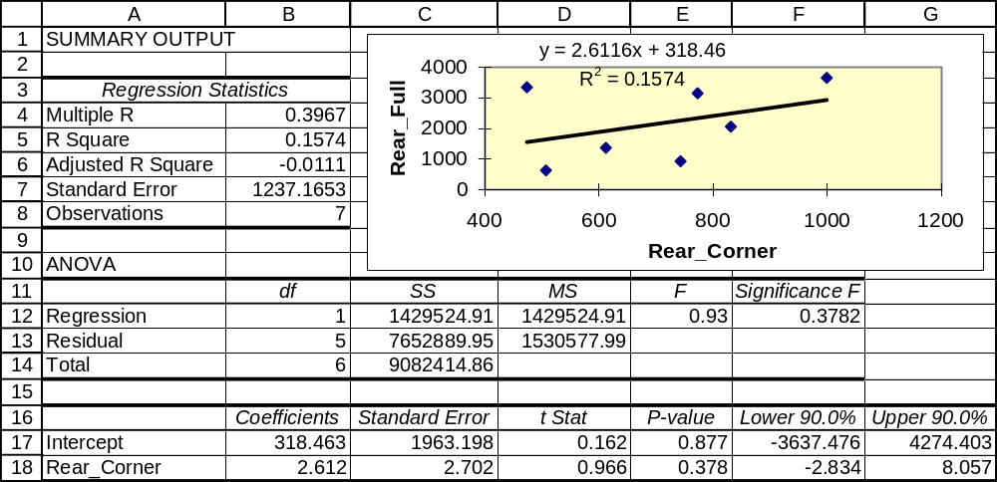

15.82 p/a/m
a. The appropriate null and alternative hypotheses are H₀: ρ = 0 and H₁: ρ ≠ 0.
This is a two-tail t-test at the α = 0.10 level and 7 - 2 = 5 degrees of freedom. The critical values of t are t = -2.015 and t = +2.015. The solution to Exercise 15.81 showed the coefficient of correlation to be r = 0.397. The calculated value of the test statistic is:
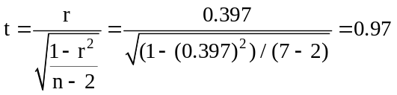
The calculated t = 0.97 is well within the critical values shown above, and we do not reject H₀.
In the solution to Exercise 15.81, Minitab has already calculated the p-value for this test as 0.378. Since p-value = 0.378 is not < α = 0.10 level of significance for the test, we do not reject H₀.
We conclude that the population coefficient of correlation could be zero.

b. The appropriate null and alternative hypotheses are H₀: β₁ = 0 and H₁: β₁ ≠ 0.
Minitab has already calculated the p-value for this test as 0.378. Since p-value = 0.378
is not < α = 0.10 level of significance for the test, we do not reject H₀. We conclude that the slope of the population regression equation could be zero.

c. The 90% confidence interval for the slope of the population regression equation is:
b₁ ± t= 2.612 ± 2.015(2.702) = 2.612 ± 5.445, or from -2.83 to 8.06. The interval includes zero, and we conclude that the population regression slope could be zero. This conclusion is consistent with the results of the hypothesis test in part b. We can also find this interval by referring to the Excel printout in the solution to Exercise 15.81. See cells F18:G18.

15.83 p/a/m
a. The regression equation is: STRENGTH = 60.02 + 10.507 TEMPTIME
b. 53% of the variation in strength is explained by the regression. (See R-sq.)
c. The slope of the line differs from zero at the 0.017 level of significance. Minitab used a
two-tail t-test to reach this conclusion.
d. The coefficient of correlation differs from zero at the 0.017 level (using the output from
the ANOVA table). This is the same level seen in part c. They will always be the same
because they are testing essentially the same thing.
e. The 95% confidence interval for the slope of the regression line is:
b₁ ± t= 10.507 ± 2.306(3.496) = 10.507 ± 8.062, or from 2.445 to 18.569.

15.84 d/p/m The SS/Regression (1777.4) is the amount of variation in y (the strength of steel bars) explained by the regression. The SS/Error (1574.6) is the amount of variation in y that is not explained by the regression, and the SS/Total (3352.0) is the total variation in y. The F value is the calculated value of the F statistic to test the coefficient of correlation using the ANOVA approach.

15.85 p/a/m
a. The least squares regression line is: ROLRESIS = 9.450 - 0.08113 PSI.
b. 23.9% of the variation in rolling resistance is explained by the regression line. (See R-sq.)
c. The slope of the line differs from zero at the 0.029 level of significance. Minitab used a
two-tail t-test to reach this conclusion.
d. The coefficient of correlation differs from zero at the 0.029 level of significance. (See the
ANOVA table.) This is the same level found in part c. These levels will always be the
same because the tests are equivalent.
e. The 95% confidence interval for the slope of the population regression line is:
b₁ ± t= -0.08113 ± 2.101(0.03416) = -0.08113 ± 0.07177, or from -0.15290 to -0.00936.

15.86 d/p/m The SS/Regression (4.3766) is the amount of variation in y (rolling resistance) that is explained by the regression. The SS/Error (13.9657) is the amount of variation in y that is not explained by the regression. The SS/Total (18.3422) is the total variation in y. The F value is the calculated value of the F statistic to test the correlation coefficient using the ANOVA approach.

15.87 p/a/m The solution could be obtained with formulas and a calculator, but we will use Minitab:

Regression Analysis: Sold versus Score

The regression equation is Sold = - 7.62 + 0.436 Score

Predictor Coef SE Coef T P
Constant -7.616 8.421 -0.90 0.432
Score 0.4363 0.1275 3.42 0.042

S = 7.23300 R-Sq = 79.6% R-Sq(adj) = 72.8%

Analysis of Variance
Source DF SS MS F P
Regression 1 613.05 613.05 11.72 0.042
Residual Error 3 156.95 52.32
Total 4 770.00

Predicted Values for New Observations
New
Obs Fit SE Fit 95% CI 95% PI
1 18.56 3.24 (8.26, 28.87) (-6.66, 43.78)

Values of Predictors for New Observations
New
Obs Score
1 60.0

The 95% confidence interval is from 8.26 to 28.87. For all individuals who score 60 on the sales aptitude test, we are 95% confident that their mean sales performance will be between 8.26 and 28.87 units.
The 95% prediction interval is from -6.66 to 43.78. For an individual scoring 60 on the sales aptitude test, we are 95% confident that this person’s sales performance will be between -6.66 and 43.78 units. As a practical matter (barring returns), the lower limit can be considered to be 0, since the individual cannot sell a negative number of units.

15.88 p/a/m The solution could be obtained with formulas and a calculator, but we will use Minitab:

Regression Analysis: 1yr_% versus 3yr_%/yr

The regression equation is 1yr_% = - 2.01 + 1.45 3yr_%/yr

Predictor Coef SE Coef T P
Constant -2.0065 0.5829 -3.44 0.041
3yr_%/yr 1.45411 0.09351 15.55 0.001

S = 0.382033 R-Sq = 98.8% R-Sq(adj) = 98.4%

Analysis of Variance
Source DF SS MS F P
Regression 1 35.294 35.294 241.82 0.001
Residual Error 3 0.438 0.146
Total 4 35.732

Predicted Values for New Observations
New
Obs Fit SE Fit 90% CI 90% PI
1 8.172 0.197 (7.710, 8.635) (7.161, 9.183)

Values of Predictors for New Observations
New
Obs 3yr_%/yr
1 7.00

The 90% confidence interval is from 7.710 to 8.635. For all such mutual funds with an annualized 3-year rate of return of 7.0 percent, we are 90% confident that their mean 1-year rate of return will be between 7.710 and 8.635 percent.
The 90% prediction interval is from 7.161 to 9.183. For an individual mutual fund with an annualized
3-year rate of return of 7.0 percent, we are 90% confident that this mutual fund’s 1-year rate of return will be between 7.161 and 9.183 percent.

15.89 p/a/m The solution could be obtained with formulas and a calculator, but we will use Minitab:

Regression Analysis: furniture versus h_starts

The regression equation is furniture = 23.5 + 20.5 h_starts

Predictor Coef SE Coef T P
Constant 23.548 6.222 3.78 0.032
h_starts 20.451 4.146 4.93 0.016

S = 1.51008 R-Sq = 89.0% R-Sq(adj) = 85.4%

Analysis of Variance
Source DF SS MS F P
Regression 1 55.491 55.491 24.33 0.016
Residual Error 3 6.841 2.280
Total 4 62.332

Predicted Values for New Observations
New
Obs Fit SE Fit 95% CI 95% PI
1 52.179 0.776 (49.710, 54.647) (46.776, 57.581)

Values of Predictors for New Observations
New
Obs h_starts
1 1.40

The 95% confidence interval is from 49.710 to 54.647. For all years in which there are 1.4 million housing starts, we are 95% confident that the mean value of retail furniture store sales will be between $49.710 and $54.647 billion.
The 95% prediction interval is from 46.776 to 57.581. For any given year in which there are 1.4 million housing starts, we are 95% confident that the value of retail furniture store sales during that year will be between $46.776 and $57.581 billion.

15.90 d/p/m This result involves extrapolating beyond the range of x values used to estimate the regression equation. Extrapolating beyond the range of the underlying x values can be dangerous.

15.91 p/c/m The Minitab printout is shown below.

Regression Analysis: Fr GPA versus SAT Total

The regression equation is Fr GPA = - 0.696 + 0.00333 SAT Total

Predictor Coef SE Coef T P
Constant -0.6964 0.9938 -0.70 0.510
SAT Total 0.0033282 0.0008991 3.70 0.010

S = 0.333948 R-Sq = 69.5% R-Sq(adj) = 64.5%

Analysis of Variance
Source DF SS MS F P
Regression 1 1.5281 1.5281 13.70 0.010
Residual Error 6 0.6691 0.1115
Total 7 2.1972

Predicted Values for New Observations
New
Obs Fit SE Fit 99% CI 99% PI
1 2.965 0.118 (2.527, 3.402) (1.651, 4.278)

Values of Predictors for New Observations
New SAT
Obs Total
1 1100

a. The regression equation is Fr GPA = - 0.6964 + 0.0033282*SAT Total. The predicted freshman grade point average for an applicant who has scored a total of 1100 on his SAT examination
is -0.6964 + 0.0033282(1100) = 2.965. See the “Fit” column of the Minitab printout.
b. The SAT scores explain 69.5% of the variation in the freshman grade point averages.
c. The 99% confidence interval is from 2.527 to 3.402. For all those scoring 1100 on their SAT exam, we are 99% confident that their mean freshman grade point average will be between 2.527 and 3.402.
The 99% prediction interval is from 1.651 to 4.278. For an individual who has scored 1100 on her SAT exam, we are 99% confident that her freshman grade point average will be between 1.651 and 4.278.

The corresponding Excel printout and plot are shown below.
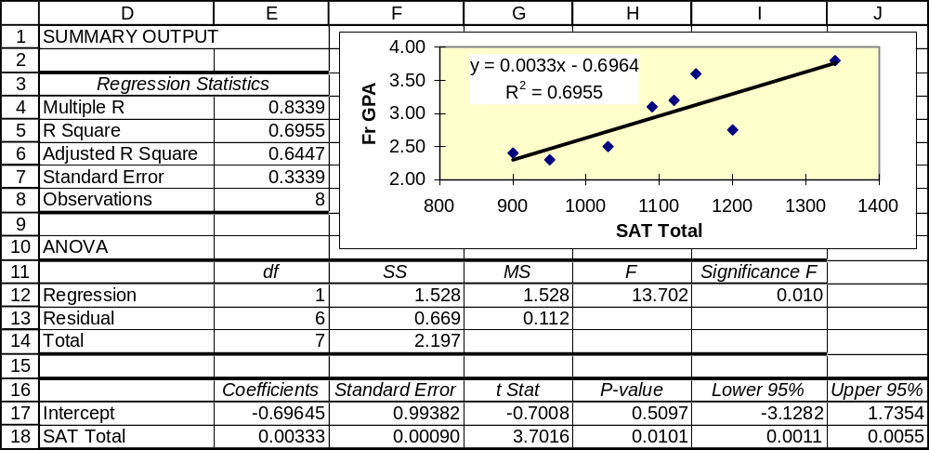

15.92 p/c/m
a. The histogram of residuals seems relatively normal. However, this is based on visual examination and the number of data values is very small, so we will rely on the Minitab normality test in part (b).
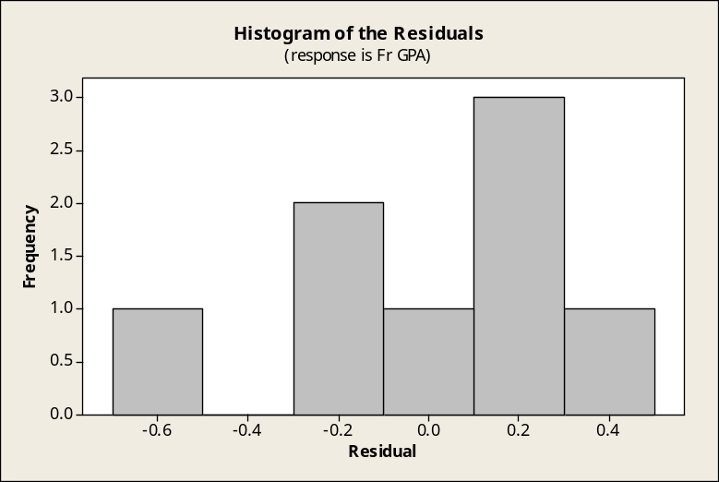

b. The normal probability plot as carried out by the Minitab normality test. The approximate p-value is shown as > 0.15. If we were to use a level of significance such as 0.05 or 0.10, we would conclude that the residuals could have come from a normal population.
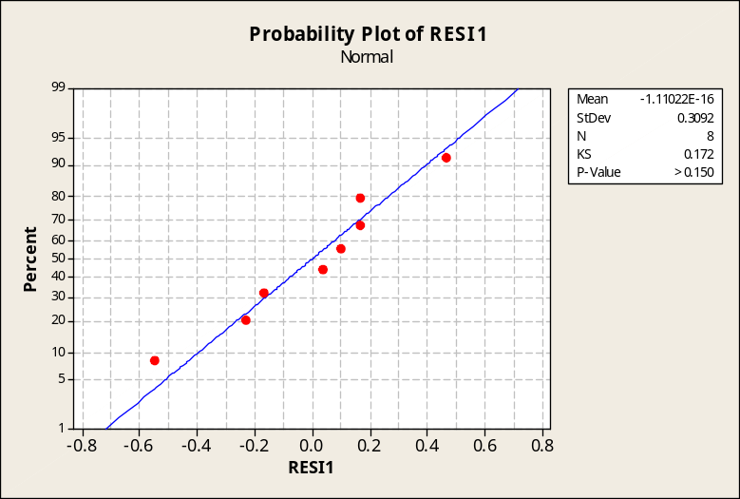

c. Plot of residuals versus the x values. No unusual patterns seem to be present.
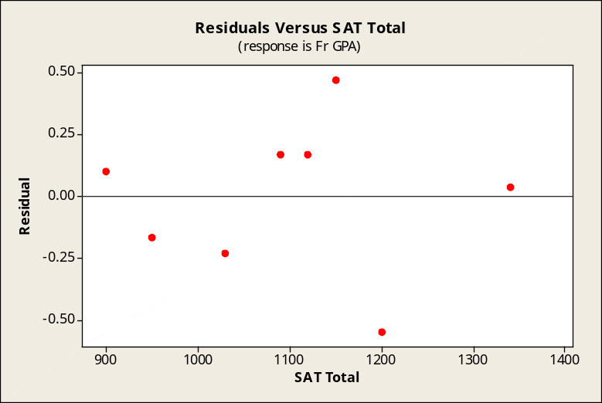

d. Plot of residuals versus the order of the data. No unusual patterns seem to be present.
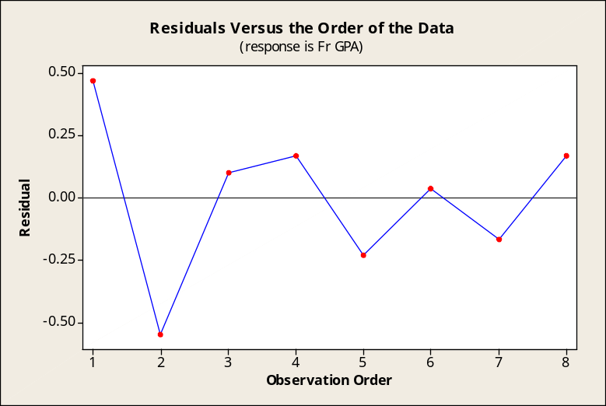

15.93 p/c/m The Minitab printout is shown below.

Regression Analysis: Pay% versus Rate%
The regression equation is Pay% = 7.02 + 1.52 Rate%

Predictor Coef SE Coef T P
Constant 7.0202 0.6124 11.46 0.000
Rate% 1.51597 0.07629 19.87 0.000

S = 0.219955 R-Sq = 98.0% R-Sq(adj) = 97.8%

Analysis of Variance
Source DF SS MS F P
Regression 1 19.102 19.102 394.83 0.000
Residual Error 8 0.387 0.048
Total 9 19.489

Unusual Observations
Obs Rate% Pay% Fit SE Fit Residual St Resid
1 10.0 22.0000 22.2405 0.1722 -0.2405 -1.76 X
X denotes an observation whose X value gives it large influence.

Predicted Values for New Observations
New
Obs Fit SE Fit 95% CI 95% PI
1 19.1479 0.0696 (18.9874, 19.3084) (18.6159, 19.6799)

Values of Predictors for New Observations
New
Obs Rate%
1 8.00
a. The regression equation is Pay% = 7.0202 + 1.51597*Rate%. If the average mortgage rate is 8.0%,
the predicted average monthly mortgage payment as a percentage of median household income will be 7.0202 + 1.51597(8) = 19.1479%. See the “Fit” column of the Minitab printout.
b. The mortgage rate percentages explain 98.0% of the variation in mortgage affordability.
The p-value (0.000) for the test of the slope is less than the 0.05 level of significance. At this level,
we conclude that the slope of the population regression equation is not zero.
c. The 95% confidence interval is from 18.9874 to 19.3084. For all years in which the average mortgage rate is 8.0%, we are 95% confident that the mean mortgage affordability for these years will be between 18.9874% and 19.3084%.
The 95% prediction interval is from 18.6159 to 19.6799. For a given year in which the average mortgage rate is 8.0%, we are 95% confident that the mortgage affordability for this year will be between 18.6159% and 19.6799%.
The corresponding Excel printout and plot are shown below.
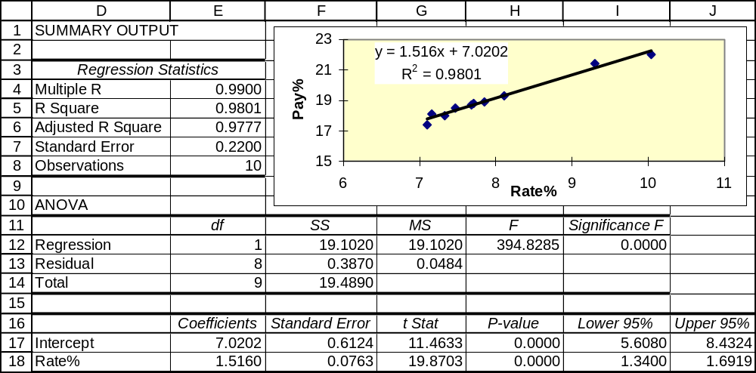

15.94 p/c/m
a. The histogram of residuals seems relatively normal. However, this is based on visual examination and the number of data values is very small, so we will rely on the Minitab normality test in part (b).
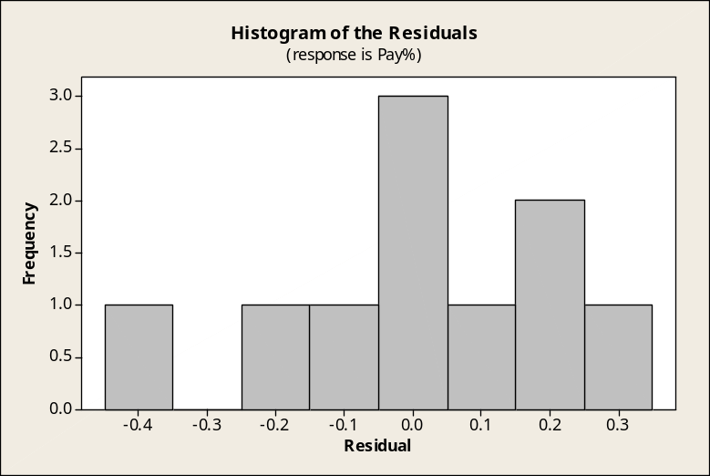

b. The normal probability plot as carried out by the Minitab normality test. The approximate p-value is shown as > 0.15. If we were to use a level of significance such as 0.05 or 0.10, we would conclude that the residuals could have come from a normal population.
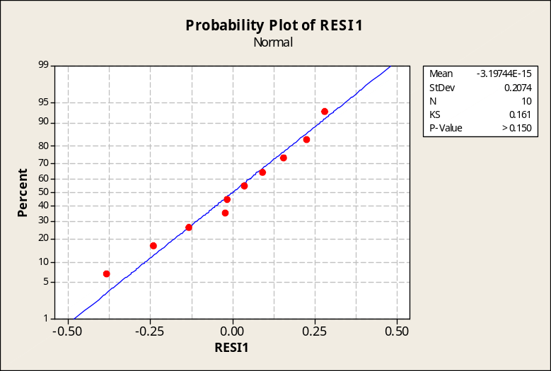

c. Plot of residuals versus the x values. No unusual patterns seem to be present.
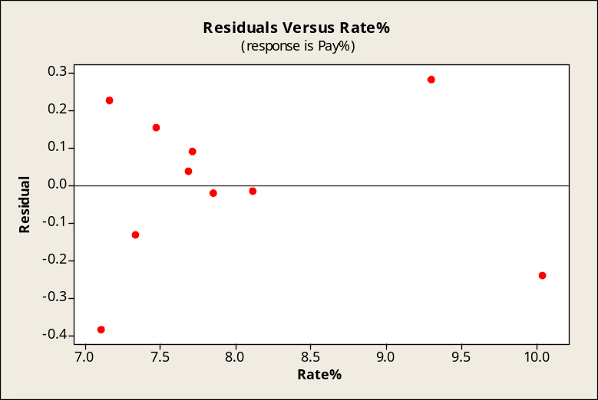

d. Plot of residuals versus the order of the data. No unusual patterns seem to be present.
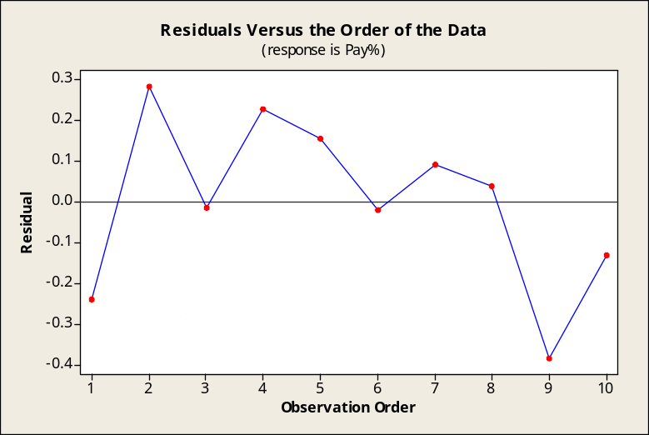

15.95 p/c/m The Minitab printout is shown below.

Regression Analysis: Est P/E Ratio versus Revenue%Growth

The regression equation is Est P/E Ratio = 52.6 - 0.096 Revenue%Growth

96 cases used, 4 cases contain missing values

Predictor Coef SE Coef T P
Constant 52.56 15.01 3.50 0.001
Revenue%Growth -0.0959 0.2132 -0.45 0.654

S = 63.9697 R-Sq = 0.2% R-Sq(adj) = 0.0%

Analysis of Variance
Source DF SS MS F P
Regression 1 828 828 0.20 0.654
Residual Error 94 384660 4092
Total 95 385488

Unusual Observations
Est
P/E
Obs Revenue%Growth Ratio Fit SE Fit Residual St Resid
3 117 245.00 41.33 13.17 203.67 3.25R
4 80 286.00 44.88 7.43 241.12 3.79R
8 71 363.00 45.75 6.73 317.25 4.99R
12 132 10.00 39.90 16.03 -29.90 -0.48 X
13 55 176.00 47.28 6.77 128.72 2.02R
14 221 3.00 31.36 34.24 -28.36 -0.52 X
21 134 17.00 39.70 16.42 -22.70 -0.37 X
63 33 309.00 49.39 9.20 259.61 4.10R
R denotes an observation with a large standardized residual.
X denotes an observation whose X value gives it large influence.

Predicted Values for New Observations
New
Obs Fit SE Fit 95% CI 95% PI
1 38.17 19.59 (-0.74, 77.07) (-94.67, 171.01)X
X denotes a point that is an outlier in the predictors.

Values of Predictors for New Observations
New
Obs Revenue%Growth
1 150

a. The regression equation is Est P/E Ratio = 52.56 - 0.0959*Revenue%Growth. A company whose annual revenue growth has been 150% would have a predicted P/E ratio of 52.56 - 0.0959(150) = 38.17. See the “Fit” column of the Minitab printout.
b. Annual revenue growth percentage explains only 0.2% of the variation in the P/E estimates.
The p-value (0.654) for the test of the slope is not less than the 0.05 level of significance. At this level, we conclude that the slope of the population regression equation could be zero.
c. The 95% confidence interval is from -0.74 to 77.07. For all companies having an annual revenue growth of 150%, we are 95% confident that the mean P/E estimate for these companies will be between -0.74 and 77.07.
The 95% prediction interval is from -94.67 to 171.01. For an individual company having an annual revenue growth of 150%, we are 95% confident that this company’s P/E estimate will be between
-94.67 and 171.01.

The corresponding Excel printout and plot are shown below. Note: Before carrying out the Excel regression analysis, it will be necessary to delete the four cases for which there is missing data on these variables.
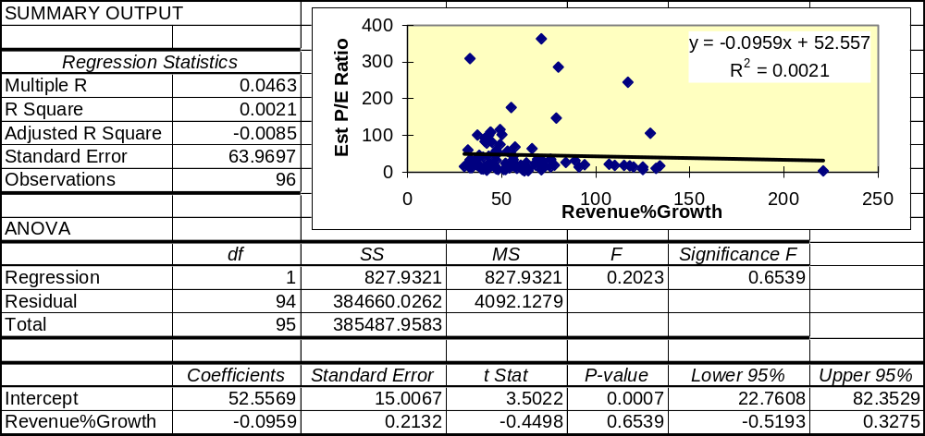
15.96 p/c/m
a. The histogram of residuals suggests that they may not have come from a normal population.
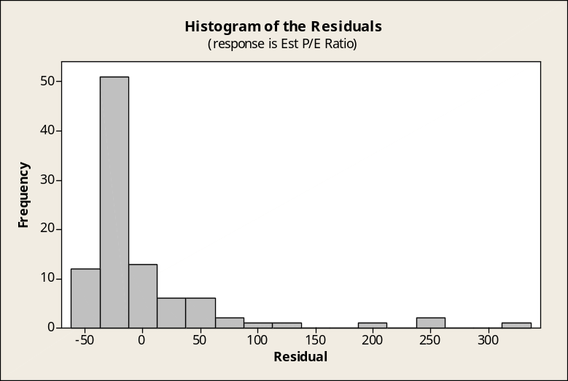

b. The normal probability plot as carried out by the Minitab normality test. The approximate p-value is shown as < 0.010. It appears that the residuals did not come from a normal population.
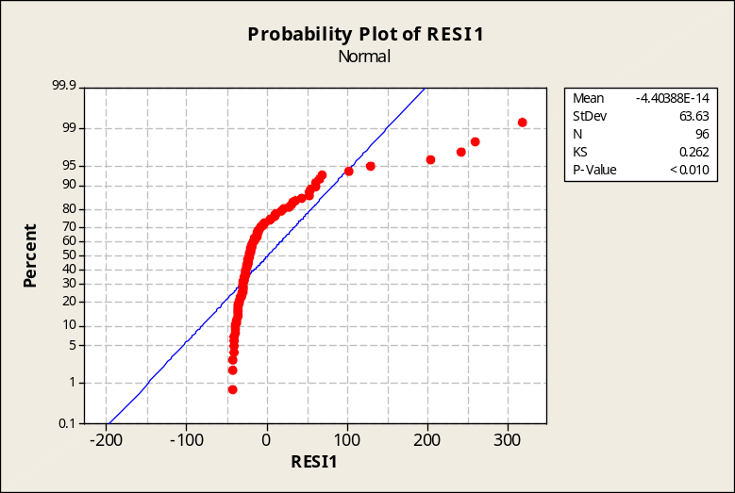

c. Plot of residuals versus the x values. They do not appear to be randomly scattered above and below the “0” line.
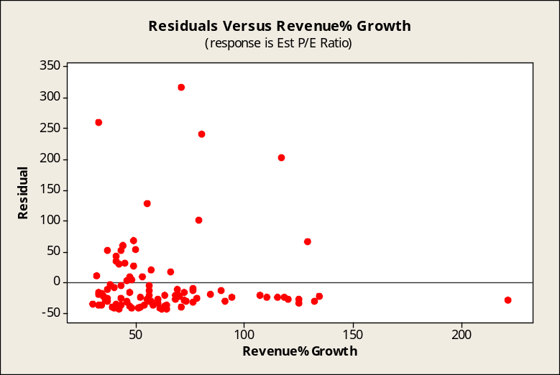

d. Plot of residuals versus the order of the data. The points do not appear to be randomly scattered above and below the “0” line. There are a lot of large positive residuals, but no large negative residuals.
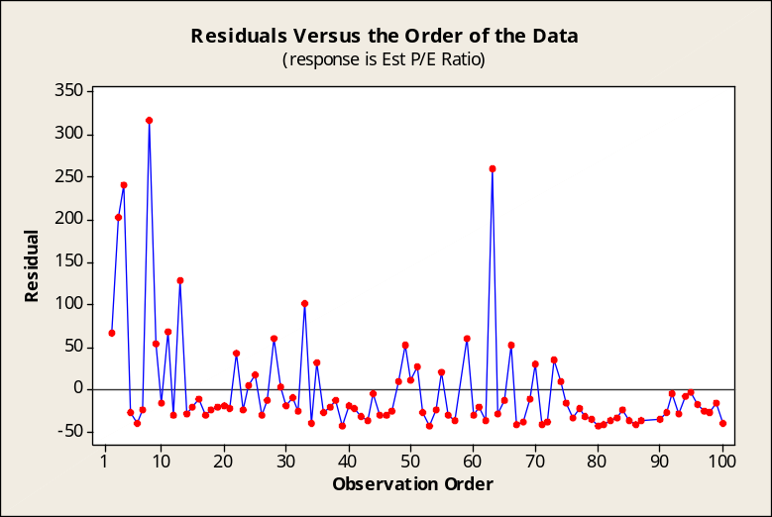

INTEGRATED CASES

THORNDIKE SPORTS EQUIPMENT MINICASE

Ted will run some simple linear regressions examining the relationship between the year a race was held and its winning time. He thinks that the times will decrease as the years increase due to bigger, faster athletes and improved training technologies.

1. Ted runs a regression with the women's winning time in the 400-meter freestyle for the Olympics held from 1924 to 2008 as the dependent variable, and the year as the independent variable.

Regression Analysis: Women400 versus Year

The regression equation is Women400 = 51.4 - 0.0237 Year

Predictor Coef SE Coef T P
Constant 51.417 3.378 15.22 0.000
Year -0.023747 0.001716 -13.84 0.000

S = 0.194815 R-Sq = 91.4% R-Sq(adj) = 90.9%

Analysis of Variance
Source DF SS MS F P
Regression 1 7.2706 7.2706 191.57 0.000
Residual Error 18 0.6832 0.0380
Total 19 7.9537

Predicted Values for New Observations
New
Obs Fit SE Fit 95% CI 95% PI
1 3.5430 0.0926 (3.3485, 3.7374) (3.0898, 3.9961)

Values of Predictors for New Observations
New
Obs Year
1 2016

The regression equation is Women400 = 51.417 - 0.023747*Year. The negative slope implies that the times do decrease as the year increases. Since the slope is negative and r² = 0.914, the coefficient of correlation is r = -0.956. This indicates a strong inverse relationship between the year and the winning race time. The point estimate for the winning time in the women's 400-meter freestyle in the year 2016 is 3.5430 minutes. See the "Fit" column in the Minitab printout. The 95% prediction interval for the winning time in the women's 400-meter freestyle in the year 2016 is from 3.0898 to 3.9961 minutes. See the "PI" column in the Minitab printout.

2. Ted runs the same regression using the men's time as the dependent variable.

Regression Analysis: Men400 versus Year

The regression equation is Men400 = 38.8 - 0.0176 Year

Predictor Coef SE Coef T P
Constant 38.820 1.860 20.88 0.000
Year -0.0175890 0.0009446 -18.62 0.000

S = 0.107258 R-Sq = 95.1% R-Sq(adj) = 94.8%

Analysis of Variance
Source DF SS MS F P
Regression 1 3.9887 3.9887 346.71 0.000
Residual Error 18 0.2071 0.0115
Total 19 4.1958

Unusual Observations
Obs Year Men400 Fit SE Fit Residual St Resid
20 2008 3.6980 3.5014 0.0444 0.1966 2.01R
R denotes an observation with a large standardized residual.

Predicted Values for New Observations
New
Obs Fit SE Fit 95% CI 95% PI
1 3.3607 0.0510 (3.2536, 3.4678) (3.1112, 3.6102)

Values of Predictors for New Observations
New
Obs Year
1 2016

The regression equation is Men400 = 38.820 - 0.0175890*Year. The negative slope implies that the times are falling as the year increases. Since the slope is negative and r² = 0.951, the coefficient of correlation is r = -0.975. This indicates a strong inverse relationship between the year and the winning race time.
The point estimate for the winning time in the men's 400-meter freestyle in the year 2016 is 3.3607 minutes. See the "Fit" column in the Minitab printout. The 95% prediction interval for the winning time in the men's 400-meter freestyle in the year 2016 is from 3.1112 to 3.6102 minutes. See the "PI" column in the Minitab printout.

3. Ted regresses women's time (dependent variable) against men's time (independent variable).

Regression Analysis: Women400 versus Men400

The regression equation is Women400 = - 1.06 + 1.37 Men400

Predictor Coef SE Coef T P
Constant -1.0602 0.1732 -6.12 0.000
Men400 1.36579 0.04100 33.31 0.000

S = 0.0839908 R-Sq = 98.4% R-Sq(adj) = 98.3%

Analysis of Variance
Source DF SS MS F P
Regression 1 7.8267 7.8267 1109.47 0.000
Residual Error 18 0.1270 0.0071
Total 19 7.9537

Unusual Observations
Obs Men400 Women400 Fit SE Fit Residual St Resid
1 5.07 6.0370 5.8644 0.0404 0.1726 2.34R
R denotes an observation with a large standardized residual.

Predicted Values for New Observations
New
Obs Fit SE Fit 95% CI 95% PI
1 3.8567 0.0309 (3.7918, 3.9216) (3.6687, 4.0447)

Values of Predictors for New Observations
New
Obs Men400
1 3.60

The regression equation is Women400 = -1.0602 + 1.36579*Men400. The positive slope implies that the women's times decrease as the men's times decrease, and vice versa. Since the slope is positive and r² = 0.984, the coefficient of correlation is r = 0.992. This indicates a very strong direct relationship between the men's times and the women's times. In a year when the men's winning time is 3.600 minutes, the point estimate for the women's winning time would be 3.8567 minutes. See the "Fit" column in the Minitab printout. In a year when the men's winning time is 3.600 minutes, the 95% prediction interval for the women's winning time is from 3.6687 to 4.0447 minutes. See the "PI" column in the Minitab printout.
4. To test the significance of the linear relationship between men's times and women's times, we can employ the hypothesis test about the coefficient of correlation or the hypothesis test about the slope coefficient. In both cases, Minitab indicates that the p-value is 0.000. This indicates a very high level of significance for the linear relationship.

SPRINGDALE SHOPPING SURVEY

1a and 2a. Dependent variable 7 (SPRILIKE), independent variable 21 (IMPVARIE), and examination of residuals.

Regression Analysis: SPRILIKE versus IMPVARIE

The regression equation is SPRILIKE = 3.06 + 0.181 IMPVARIE

Predictor Coef SE Coef T P
Constant 3.0613 0.2547 12.02 0.000
IMPVARIE 0.18138 0.04377 4.14 0.000

S = 0.737651 R-Sq = 10.4% R-Sq(adj) = 9.8%

Analysis of Variance
Source DF SS MS F P
Regression 1 9.3422 9.3422 17.17 0.000
Residual Error 148 80.5311 0.5441
Total 149 89.8733

Unusual Observations
Obs IMPVARIE SPRILIKE Fit SE Fit Residual St Resid
4 6.00 2.0000 4.1495 0.0621 -2.1495 -2.92R
20 1.00 4.0000 3.2427 0.2124 0.7573 1.07 X
24 1.00 2.0000 3.2427 0.2124 -1.2427 -1.76 X
26 2.00 4.0000 3.4240 0.1709 0.5760 0.80 X
79 2.00 5.0000 3.4240 0.1709 1.5760 2.20RX
80 2.00 2.0000 3.4240 0.1709 -1.4240 -1.98 X
146 1.00 1.0000 3.2427 0.2124 -2.2427 -3.17RX

R denotes an observation with a large standardized residual.
X denotes an observation whose X value gives it large influence.

The slope (0.181) differs from zero at a p-value of 0.000. At the 0.05 level, we are able to conclude that a linear relationship exists between attitude toward Springdale Mall and the importance of having good variety of sizes and styles. The standard error of estimate is 0.737651 and the coefficients of determination and correlation are 0.104 and 0.322, respectively (0.098 and 0.313 after adjustment).
The histogram of the residuals suggests that they may not have come from a normal population.
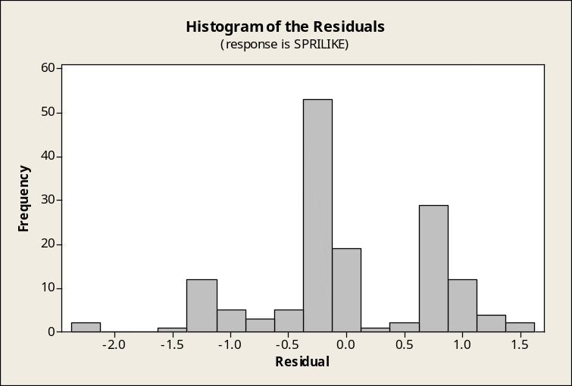

In this Minitab test for normality, the points in the normal probability plot don't appear to deviate excessively from a straight line but the approximate p-value is shown as < 0.010, which is less than the 0.05 level of significance. We conclude the residuals may not have come from a normally distributed population.
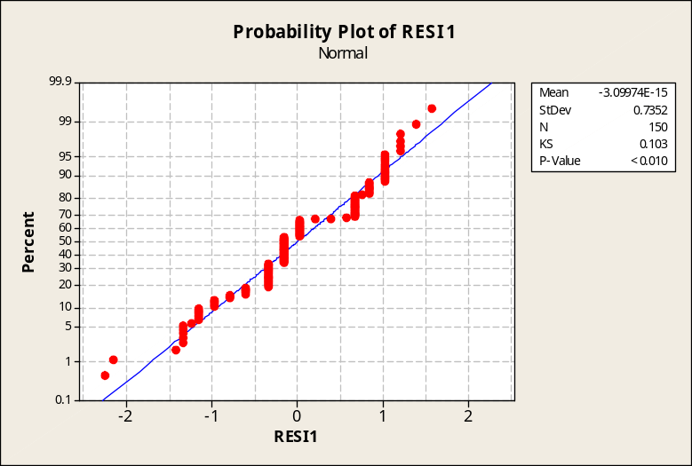

From the following plot of residuals versus the independent variable, it does not appear that the
homoscedasticity assumption has been violated.
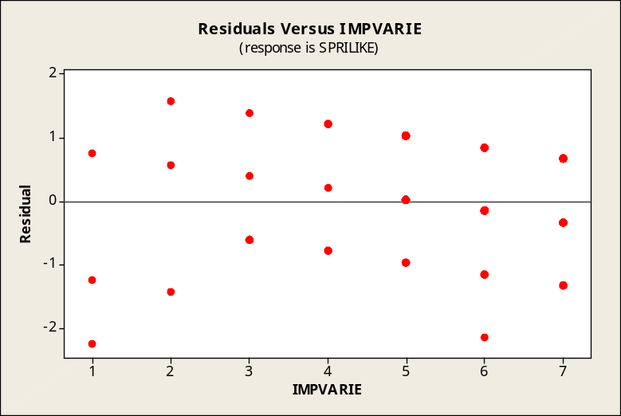

1b and 2b. Dependent variable 7 (SPRILIKE), independent variable 25 (IMPBARGN), and examination of residuals.

Regression Analysis: SPRILIKE versus IMPBARGN

The regression equation is SPRILIKE = 4.08 + 0.0011 IMPBARGN

Predictor Coef SE Coef T P
Constant 4.0802 0.2664 15.31 0.000
IMPBARGN 0.00114 0.04566 0.03 0.980

S = 0.779262 R-Sq = 0.0% R-Sq(adj) = 0.0%

Analysis of Variance
Source DF SS MS F P
Regression 1 0.0004 0.0004 0.00 0.980
Residual Error 148 89.8730 0.6072
Total 149 89.8733

Unusual Observations
Obs IMPBARGN SPRILIKE Fit SE Fit Residual St Resid
4 7.00 2.0000 4.0882 0.0881 -2.0882 -2.70R
16 1.00 4.0000 4.0813 0.2224 -0.0813 -0.11 X
20 1.00 4.0000 4.0813 0.2224 -0.0813 -0.11 X
24 5.00 2.0000 4.0859 0.0705 -2.0859 -2.69R
73 2.00 4.0000 4.0825 0.1791 -0.0825 -0.11 X
80 6.00 2.0000 4.0870 0.0654 -2.0870 -2.69R
88 1.00 3.0000 4.0813 0.2224 -1.0813 -1.45 X
111 1.00 5.0000 4.0813 0.2224 0.9187 1.23 X
140 2.00 4.0000 4.0825 0.1791 -0.0825 -0.11 X
146 7.00 1.0000 4.0882 0.0881 -3.0882 -3.99R

R denotes an observation with a large standardized residual.
X denotes an observation whose X value gives it large influence.

The slope (0.00114) differs from zero at a p-value of 0.980. At the 0.05 level, we are able to conclude that no linear relationship exists between attitude toward Springdale Mall and the importance of having a lot of bargain sales. The standard error of estimate is 0.779262 and the coefficients of determination and correlation are 0.0 and 0.0, respectively.

The histogram of the residuals suggests that they may not have come from a normal population.
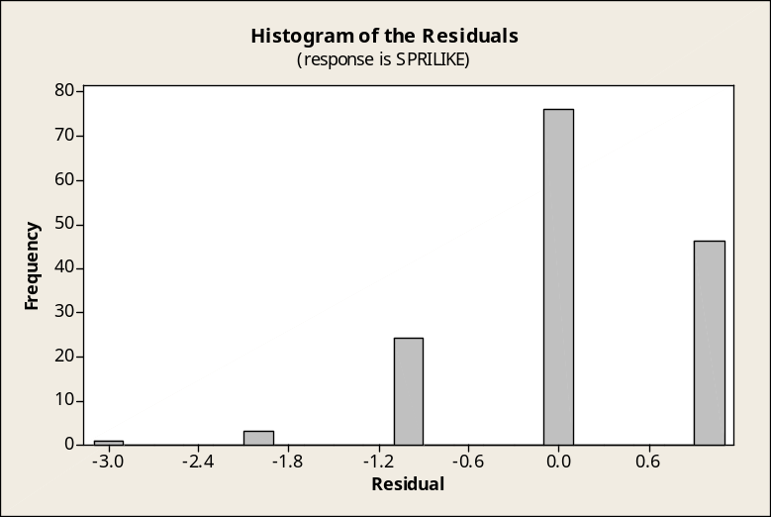

In this Minitab test for normality, the points in the normal probability plot don't appear to deviate excessively from a straight line but the approximate p-value is shown as < 0.010, which is less than the 0.05 level of significance. We conclude the residuals may not have come from a normally distributed population.
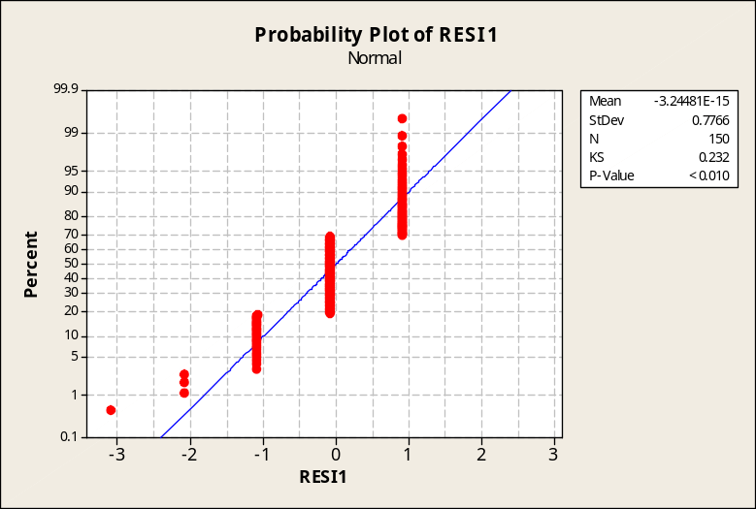

From the following plot of residuals versus the independent variable, it appears that the homoscedasticity assumption may have been violated. There seems to be a greater amount of variation in the residuals for higher values of IMPBARGN.
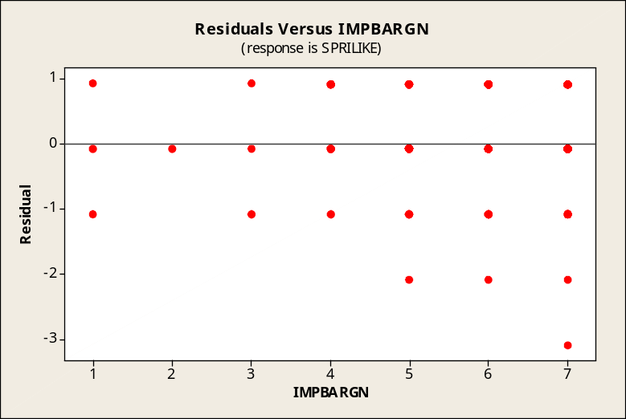

3. Repeating la and 2a for dependent variable 9 (WESTLIKE), independent variable 21 (IMPVARIE), and examination of residuals.

Regression Analysis: WESTLIKE versus IMPVARIE

The regression equation is WESTLIKE = 3.59 - 0.0605 IMPVARIE

Predictor Coef SE Coef T P
Constant 3.5886 0.3599 9.97 0.000
IMPVARIE -0.06048 0.06186 -0.98 0.330

S = 1.04246 R-Sq = 0.6% R-Sq(adj) = 0.0%

Analysis of Variance
Source DF SS MS F P
Regression 1 1.039 1.039 0.96 0.330
Residual Error 148 160.835 1.087
Total 149 161.873

Unusual Observations
Obs IMPVARIE WESTLIKE Fit SE Fit Residual St Resid
20 1.00 1.0000 3.5281 0.3002 -2.5281 -2.53RX
24 1.00 4.0000 3.5281 0.3002 0.4719 0.47 X
26 2.00 4.0000 3.4676 0.2415 0.5324 0.52 X
39 7.00 1.0000 3.1652 0.1191 -2.1652 -2.09R
56 6.00 1.0000 3.2257 0.0878 -2.2257 -2.14R
63 7.00 1.0000 3.1652 0.1191 -2.1652 -2.09R
79 2.00 5.0000 3.4676 0.2415 1.5324 1.51 X
80 2.00 5.0000 3.4676 0.2415 1.5324 1.51 X
95 7.00 1.0000 3.1652 0.1191 -2.1652 -2.09R
108 6.00 1.0000 3.2257 0.0878 -2.2257 -2.14R
111 4.00 1.0000 3.3467 0.1331 -2.3467 -2.27R
121 7.00 1.0000 3.1652 0.1191 -2.1652 -2.09R
122 7.00 1.0000 3.1652 0.1191 -2.1652 -2.09R
123 7.00 1.0000 3.1652 0.1191 -2.1652 -2.09R
146 1.00 1.0000 3.5281 0.3002 -2.5281 -2.53RX

R denotes an observation with a large standardized residual.
X denotes an observation whose X value gives it large influence.

The slope (-0.0605) differs from zero at a p-value of 0.330. At the 0.05 level, we conclude that no linear relationship exists between attitude toward West Mall and the importance of a good variety of sizes and styles. The standard error of estimate is 1.04246 and the coefficients of determination and correlation are 0.006 and -0.077, respectively (0.0 and 0.0 after adjustment). Because the slope is negative, the coefficient of correlation is also negative.

The histogram of the residuals suggests they may not have come from a normal population.
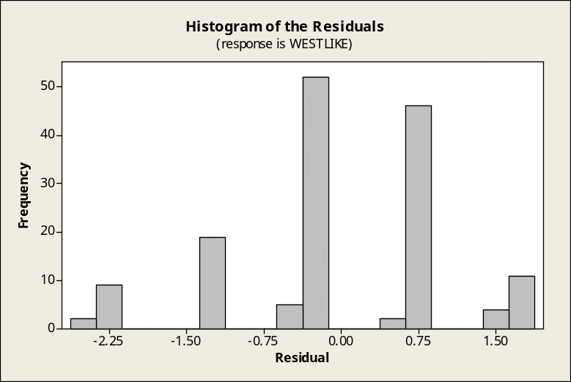

In this Minitab test for normality, the points in the normal probability plot don't appear to deviate excessively from a straight line but the approximate p-value is shown as < 0.010, which is less than the 0.05 level of significance. We conclude the residuals may not have come from a normally distributed population.
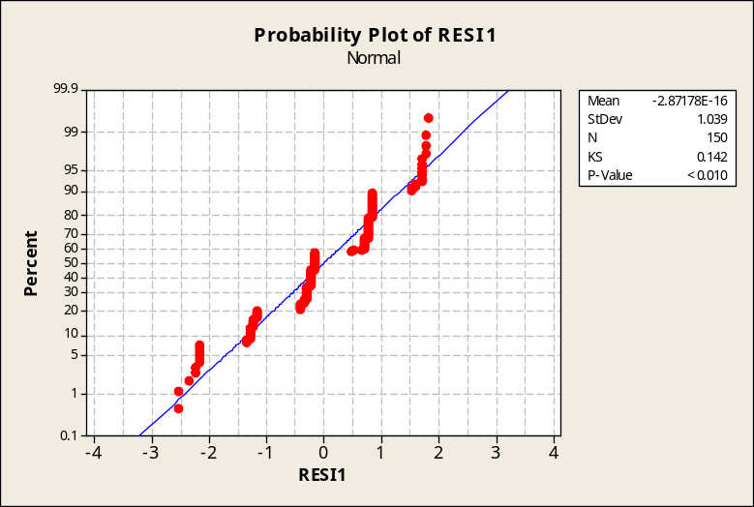

From the following plot of residuals versus the independent variable, it appears that the homoscedasticity assumption may have been violated.
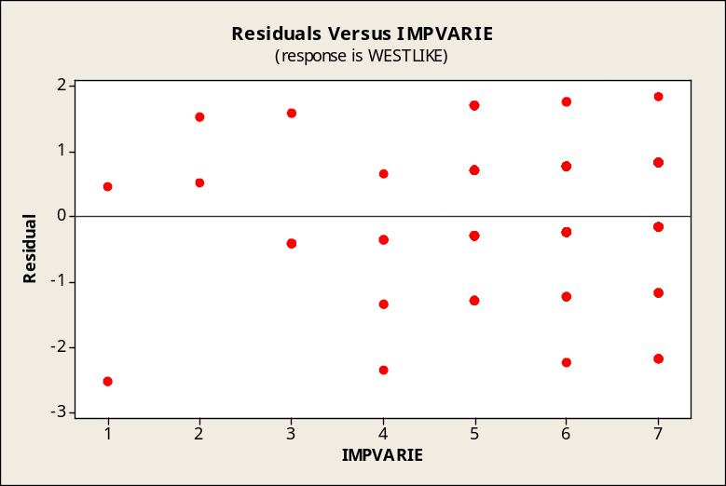

3. Repeating lb and 2b for dependent variable 9 (WESTLIKE), independent variable 25 (IMPBARGN), and examination of residuals.

Regression Analysis: WESTLIKE versus IMPBARGN

The regression equation is WESTLIKE = 2.60 + 0.114 IMPBARGN

Predictor Coef SE Coef T P
Constant 2.5983 0.3533 7.35 0.000
IMPBARGN 0.11442 0.06055 1.89 0.061

S = 1.03343 R-Sq = 2.4% R-Sq(adj) = 1.7%

Analysis of Variance
Source DF SS MS F P
Regression 1 3.814 3.814 3.57 0.061
Residual Error 148 158.059 1.068
Total 149 161.873

Unusual Observations
Obs IMPBARGN WESTLIKE Fit SE Fit Residual St Resid
16 1.00 2.0000 2.7127 0.2949 -0.7127 -0.72 X
20 1.00 1.0000 2.7127 0.2949 -1.7127 -1.73 X
39 7.00 1.0000 3.3992 0.1168 -2.3992 -2.34R
56 6.00 1.0000 3.2848 0.0868 -2.2848 -2.22R
63 6.00 1.0000 3.2848 0.0868 -2.2848 -2.22R
73 2.00 2.0000 2.8271 0.2375 -0.8271 -0.82 X
88 1.00 3.0000 2.7127 0.2949 0.2873 0.29 X
95 7.00 1.0000 3.3992 0.1168 -2.3992 -2.34R
108 6.00 1.0000 3.2848 0.0868 -2.2848 -2.22R
111 1.00 1.0000 2.7127 0.2949 -1.7127 -1.73 X
121 6.00 1.0000 3.2848 0.0868 -2.2848 -2.22R
122 6.00 1.0000 3.2848 0.0868 -2.2848 -2.22R
123 5.00 1.0000 3.1704 0.0935 -2.1704 -2.11R
140 2.00 2.0000 2.8271 0.2375 -0.8271 -0.82 X
146 7.00 1.0000 3.3992 0.1168 -2.3992 -2.34R

R denotes an observation with a large standardized residual.
X denotes an observation whose X value gives it large influence.

The slope (0.114) differs from zero at a p-value of 0.061. At the 0.05 level, we conclude that no linear relationship exists between attitude toward West Mall and the importance of having a lot of bargain sales. The standard error of estimate is 1.03343 and the coefficients of determination and correlation are 0.024 and 0.155, respectively (0.017 and 0.130 after adjustment).

The histogram of the residuals suggests they may not have come from a normal population.
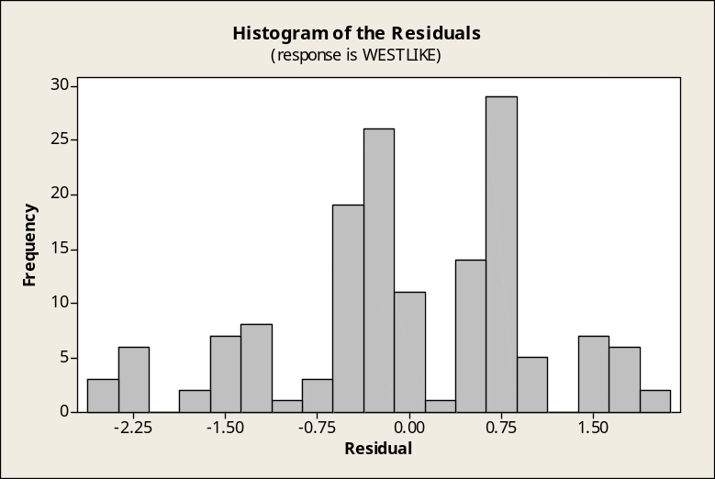

In this Minitab test for normality, the points in the normal probability plot don't appear to deviate excessively from a straight line but the approximate p-value is shown as < 0.010, which is less than the 0.05 level of significance. We conclude the residuals may not have come from a normally distributed population.
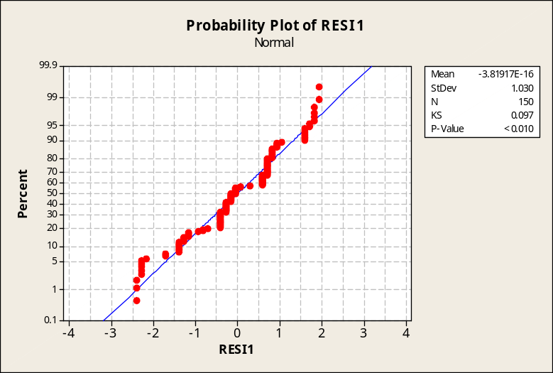

From the following plot of residuals versus the independent variable, it appears that the homoscedasticity assumption may have been violated, as there seems to be more variability in the residuals for higher values of IMPBARGN.
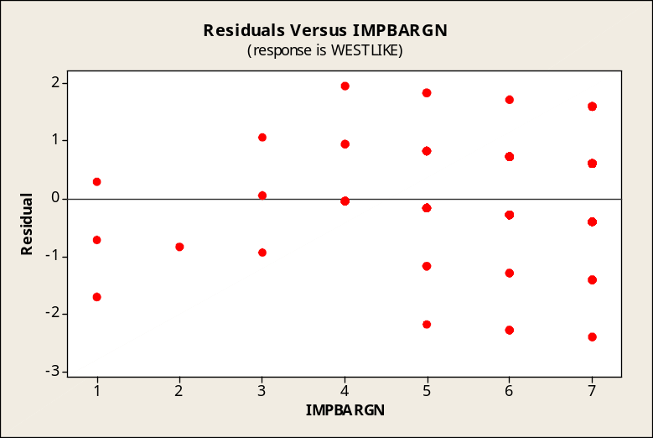

BUSINESS CASE

PRONTO PIZZA (B)

In the Pronto Pizza case, visited earlier in chapter 10, the company was concerned about being able to provide call-in customers with a guarantee as to how quickly their pizza would arrive. Manager Tony Scapelli had collected a month’s worth of data that included such variables as preparation time, wait time, travel time, and delivery distance. We will be using simple linear regression and correlation to help Tony examine the number of travel minutes for a delivery versus the number of miles involved in making the delivery. Using the PRONTO data file, and the variables Travel_Time and Distance:

1. The coefficient of correlation between Travel_Time and Distance is r = +0.936, as shown in the printout below. Deliveries involving greater distance tend to require more time, so we would expect the coefficient of correlation to be positive. The coefficient of determination is (0.936)² = 0.876, and 87.6% of the variation in driving time explained by the number of miles for the trip.

Correlations: Travel_Time, Distance
Pearson correlation of Travel_Time and Distance = 0.936
P-Value = 0.000

2. The best-fit linear regression equation for estimating Travel_Time on the basis of Distance is shown below. The slope is 1.75. Based on this model, each additional mile of distance tends to require an additional 1.75 minutes of travel time.

Regression Analysis: Travel_Time versus Distance

The regression equation is Travel_Time = 1.03 + 1.75 Distance

Predictor Coef SE Coef T P
Constant 1.0282 0.1718 5.98 0.000
Distance 1.74962 0.04270 40.97 0.000

S = 0.669440 R-Sq = 87.6% R-Sq(adj) = 87.5%

Analysis of Variance
Source DF SS MS F P
Regression 1 752.29 752.29 1678.65 0.000
Residual Error 238 106.66 0.45
Total 239 858.95

Unusual Observations
Obs Distance Travel_Time Fit SE Fit Residual St Resid
9 6.40 12.4700 12.2257 0.1154 0.2443 0.37 X
110 5.60 9.3600 10.8260 0.0847 -1.4660 -2.21R
112 2.70 7.3500 5.7521 0.0668 1.5979 2.40R
139 1.20 4.0700 3.1277 0.1229 0.9423 1.43 X
140 3.70 5.8800 7.5017 0.0440 -1.6217 -2.43R
148 3.60 8.6800 7.3268 0.0450 1.3532 2.03R
153 3.20 8.2000 6.6269 0.0524 1.5731 2.36R
165 3.10 4.6800 6.4520 0.0549 -1.7720 -2.66R
189 4.00 9.4100 8.0266 0.0434 1.3834 2.07R
191 3.00 4.8300 6.2770 0.0577 -1.4470 -2.17R
201 5.50 12.2500 10.6511 0.0811 1.5989 2.41R
213 2.50 3.9300 5.4022 0.0736 -1.4722 -2.21R
214 4.20 9.9800 8.3766 0.0451 1.6034 2.40R
224 6.40 12.5500 12.2257 0.1154 0.3243 0.49 X
227 6.40 12.5800 12.2257 0.1154 0.3543 0.54 X
234 2.90 4.7200 6.1020 0.0606 -1.3820 -2.07R
238 5.40 12.4300 10.4761 0.0775 1.9539 2.94R
R denotes an observation with a large standardized residual.
X denotes an observation whose X value gives it large influence.

Predicted Values for New Observations
New
Obs Fit SE Fit 95% CI 95% PI
1 9.7762 0.0640 (9.6501, 9.9023) (8.4514, 11.1010)

Values of Predictors for New Observations
New
Obs Distance
1 5.00
3. As shown in the printout above, the estimated time of travel for a pizza delivery that involved a 5-mile trip would be 9.7762 minutes. See the “Fit” column near the bottom of the printout.

4. We are 95% confident that the mean travel time for all delivery trips of 5 miles will be within the interval from 9.6501 to 9.9023 minutes. For any individual delivery trip of 5 miles, we are 95% confident that the delivery time for that single trip will be within the interval from 8.4514 to 11.1010 minutes.

5. In the printout, Minitab “flagged” a number of cases in which the delivery times were unusually long or short compared to the times that would have been estimated by the equation. For example, cases 165 and 140 were among those identified as taking much less time than the model would have predicted. Perhaps traffic conditions were perfect, or maybe the drivers were speeding or committing other traffic violations. In the latter possibilities, legal issues could arise if pedestrians or other drivers were injured or involved in accidents involving the pizza delivery vehicles, especially when a delivery-time guarantee is present that could used to great advantage by the plaintiff’s attorney. Also, pizza delivery vehicles with large imprinted signs are not likely to attract or retain customers when their drivers endanger, inconvenience, or annoy pedestrians or other drivers along their delivery route. Cases 112, 201, and 214 were among those cases flagged as having an unusually long delivery time than the model would have predicted. These could be cases in which traffic was congested, highway construction slowed down the delivery, or the drivers may even have stopped to make a personal telephone call or carry out a quick errand along the way.

